Report covering funding period from Apr 2006-Mar 2007

Submitted to:
New England Aquarium
Boston, MA

Submitted by:
Professor Kenneth Baldwin
Darren Landino
Center for Ocean Engineering
University of New Hampshire
Durham, NH
Introduction

This report covers the results of the UNH/OE efforts from April 01, 2006 to March 31, 2007. The topics in the work statement were all addressed, some more than others as the emphasis shifted. The tasks were: 1) Novel rope evaluation and interaction with a right whale flipper, 2) Strength testing of whale safe ropes, 3) Scale model – fishing gear interactions and, 4) Evaluation of Blue Water Concepts, Inc. (BWC) gear. The shifting emphasis resulted in Tasks 1 and 4 receiving the most effort and, Tasks 2 and 3 receiving less time. Tasks 1 and 4 are addressed first in this report, while Tasks 2 and 3 are addressed later in this report.

Task 4: Evaluation of Blue Water Concepts gear

Blue Water Concepts, Inc. of Eliot, Maine is the developer and producer of two devices which when properly configured on hauling lines can result in reducing entanglements while maintaining hauling capacity for the fishing gear. These devices are the Time Tension Line Cutter (TTLC), and the Trigger Line Cutter (TLC).

Time Tension Line Cutters
Thirty (30) model C-2 Inshore Time Tension Line Cutter (TTLC) devices were tested in the UNH Ocean Engineering Tank. These units were produced under NOAA/MNFS award EA133FO4CN0064 by Blue Water Concepts, Inc. The objective was to evaluate the operation of these devices according to product specifications and under various loading scenarios expected at sea. These units were subjected to static loading, dynamic cyclic loading and loading at reduced temperatures. The static loading was used to determine the time constant predicted by BWC. The dynamic loading was meant to simulate a struggling whale. The reduced temperature testing was done to evaluate the operation at depth where temperature is reduced.
The operation of the TTLC is based on the movement of hydraulic oil from the high pressure, loaded side of the device, to a low pressure reservoir. The flow is controlled by a valve which effects the time to cut. The secondary parameter affecting the time to cut is the viscosity of the hydraulic oil. Typically the viscosity of hydraulic oil increases at reduced temperature which increases the resistance to flow, hence the time to cut.

Test setup
The goal of this testing was to deploy the TTLC subsurface in the large tank at the Chase OE Lab at UNH, apply the various loads and measure these loads as a function of time. The test setup had two main components. The TTLC load / deployment system was entirely mechanical. The load measurement system had a digital load cell which was connected to a signal conditioner, A/D board and fed to a PC.
The load system was set up as follows: An aluminum beam was placed across the corner of the tank adjacent to the crane. From this beam, the load cell, TTLC and the load (multiple links of steamer chain) were suspended. The load cell was deployed between the ‘fixed’ beam and the TTLC. One end of the ‘active’ load was then suspended from the lower end of the TTLC, while the lower of the load was attached to the over head crane. In this way the chain could be raised and lowered, to provide either a static or dynamic load.
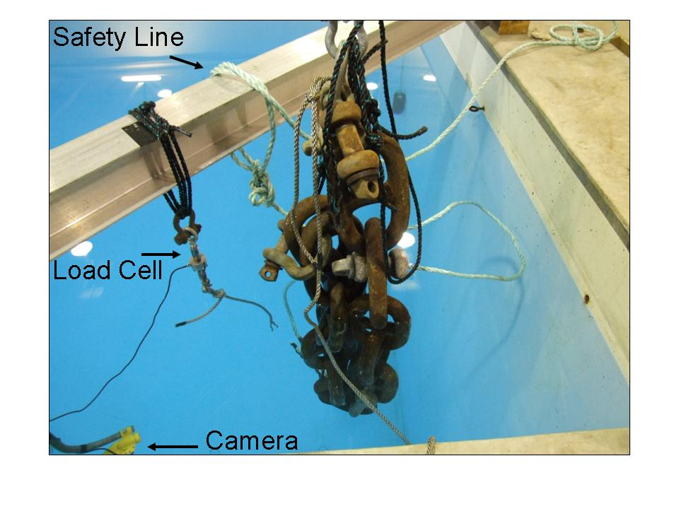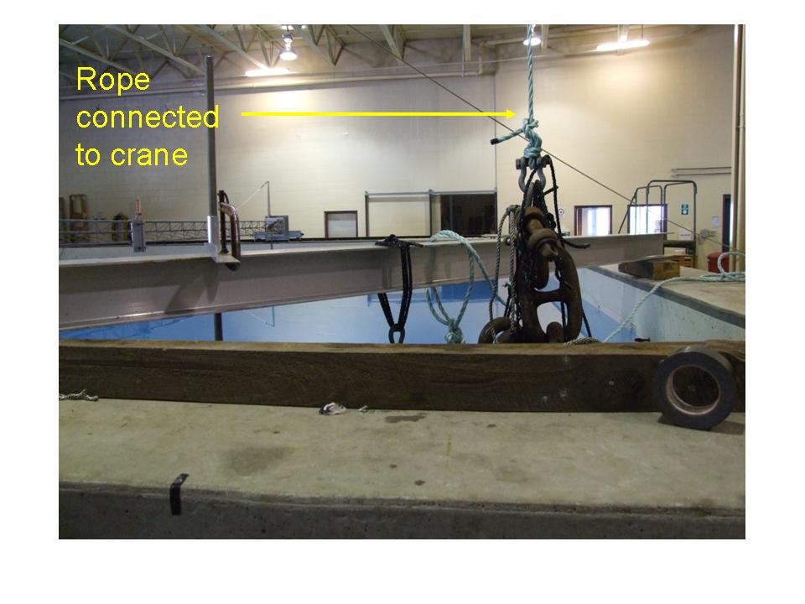
Figure 1. TTLC test set-up in the large tank at the Chase Ocean Eng Lab. The top of the large section of steamer chain was attached to the TTLC via a section of line as seen in the photo at the left. The bottom of the steamer was attached to the crane as shown in the photo at the right. The crane raised and lowered the chain changing the load on the TTLC.

The measurement system consisted of the load cell with analog output, an amplifier, an analog to digital converter, and a computer equipped with Labview measurement software (Figure 2).

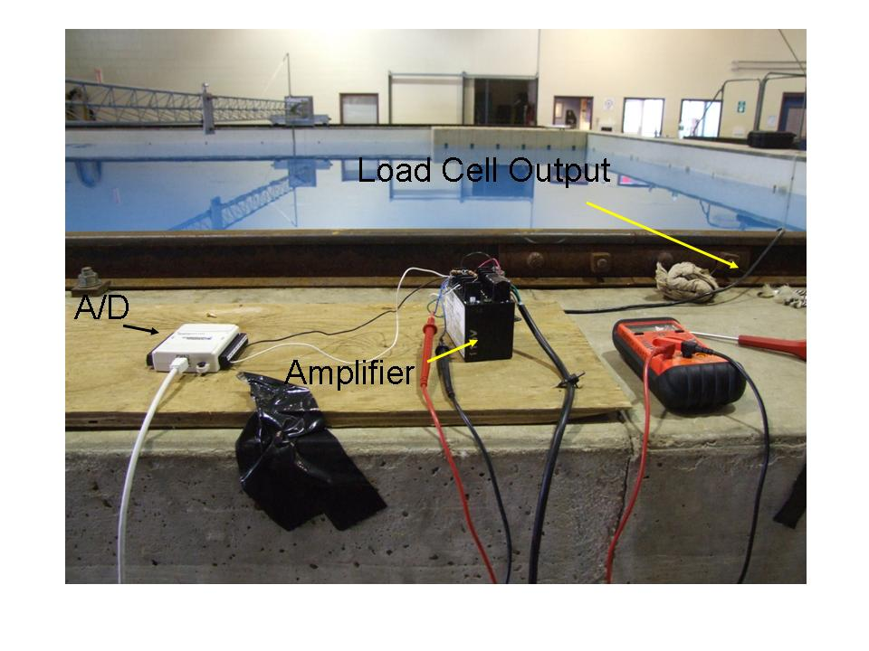
Figure 2. Basic signal conditioning components for the load cell signal are shown here. The signal from the load cell enters the amplifier and is then sent to the A/D and ultimately to the PC.

The load cell (Omega LC 203-2.5K) has a calibrated range of 0 to 2500lbs. This load cell was calibrated to NIST specifications by the manufacturer. The load cell was used in conjunction with an amplifier (Omega DMD-465) which converted the low level signal from the load cell into a 0 to 10 volt signal. The gain of amplifier was set so that 2500lbs from the load cell would result in 10V from the amplifier. The 0 to 10V signal was fed to an analog to digital converter (National Instruments NI USB-6009) which was connected by USB cable to the computer running Labview software. Labview software then displays and records the data at a rate of 2 samples per second. Identical rope was used for cutting in all the tests, Orion EZ Hauler polysteel 3/8”.
Realizing that eventually these test results would be used for evaluating the usefulness of these devices and demonstrating their operation, an underwater video of some tests was made. This video camera deployment (Figure 1) was also useful for observing the functioning of the TTLC in real time during the test.
Prior to testing, the load cell and amplifier combination was tested for gain, accuracy and linearity, using known weights. A graph of the linearity of the load cell is seen in Figure 3.

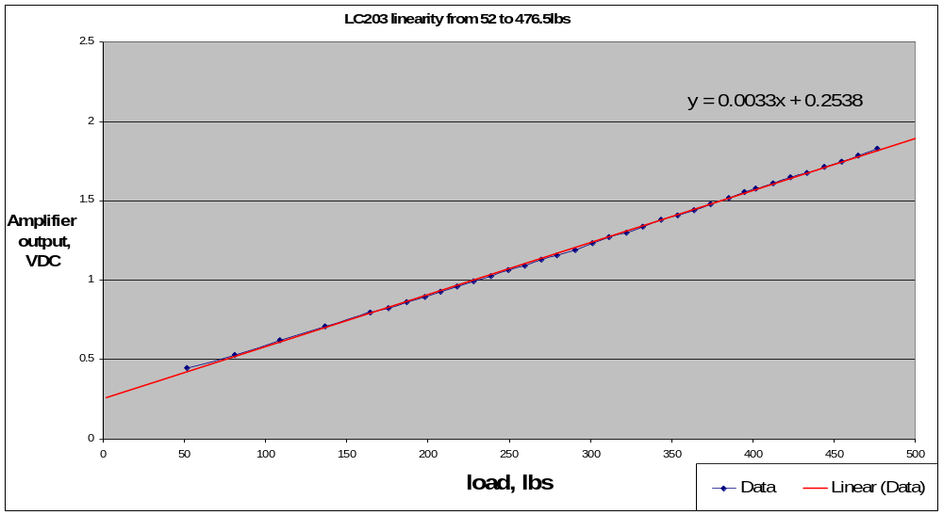
Figure 3. Plot of the load cell amplified voltage vs. load indicating the linearity of load cell.

Operational tests
Two operational tests were conducted to verify the operation of the test setup prior to the functionality testing. Two TTLC devices were selected and tested separately, using a variable load (Figure 4).
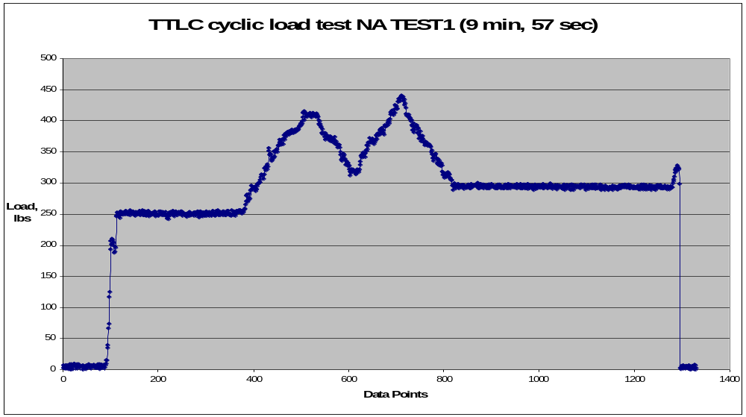

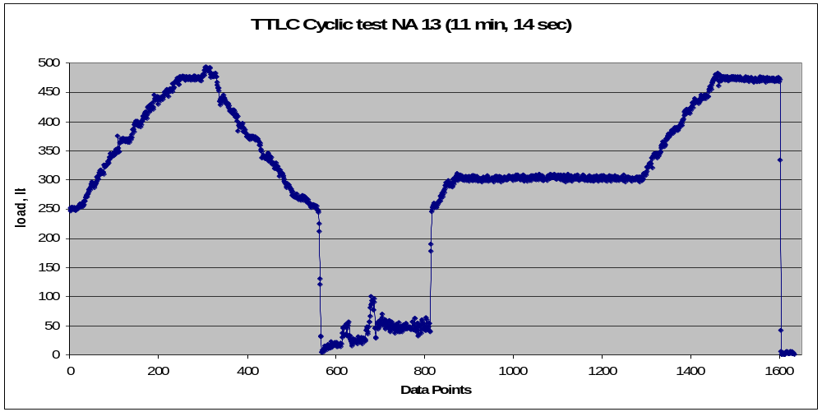
Figure 4. Representative load vs. time plots for the TTLC subjected to dynamic loading are shown here.

These tests demonstrated the ability of the test setup to create a variable and or static load, record the load, and output the data to a file. One issue that arose as an artifact of Labview was the A/D recorded two samples per second, but only recorded one time stamp for each pair of data points. For this reason, the weight is plotted vs. the number of data points, which is equal to twice the number of seconds.

Static Functionality tests
Each of the TTLC devices was tested to verify the specified time-to-cut intervals. These tests used the load chain in a static manner, around 400lbs. On some tests the weight was lower or higher, but as long as the weight was above the set threshold level of150lbs, the TTLC was able to operate and the exactness of the load did not affect the time to cut. The testing showed that all of the units cut the rope within acceptable limits of the specified time to cut. Six (6) TTLC units were tested three times each at static load to provide repeatability data. The data appear in Table 1.

Table 1. Summary of the repeat testing time to cut results.
TTLC S/N→ | NA 7 | NA10 | NA 15 | NA20 | NA 24 | NA 28
Time, Test 1 | 3m 25s | 1m 48s | 11m43s | 11m 10s | 1m 25s | 19m 33s
Time, Test 2 | 3m 47s | 1m 51s | 12m 9s | 12m 32s | 1m 49s | 19m 14s
Time, Test 3 | 3m 41s | 1m 53s | 14m 18s | 11m 43s | 1m 17s | 20m 19s

The data show consistency from each of the TTLC devices, and they show that the cutting time does not significantly decrease with successive operations.

Cyclic dynamic tests
Three of the units used for static repeatability testing were tested again for cyclic dynamic repeatability. In this test, the load chain was varied using the crane to simulate a whale alternating between periods of struggle and rest. The application of the cyclic load in time was not the same for each test (Table 2). The TTLC cut the rope in the same time frame as the static tests.

Table 2. Summary of repeat cyclic testing.
S/N | NA 15 | NA 20 | NA 28
Time, Test 1 | 15m 53s | 15m 48s | 24m 18s
Break Time, test 1 | 12m 12s | 14m 28s | 19m 58s
Time, Test 2 | 15m 33s | 17m 37s | 21m 48s
Break Time, test 2 | 11m 42s | 12m 42s | 16m 42s*
Time, Test 3 | 36m 48s | 18m 20s | 28m 36s
Break Time, test 3 | 29m 38s* | 13m 7s | 20m 31s

These data show that the TTLC cuts in a similar time frame under dynamic load. There were two anomalies, however. In the third test of NA 15, the break time was double of what was expected. This was the seventh cut for this device, so an examination of the blade was performed. The device was revealed to have a chipped cutting blade. Further examination of the other devices which had more than five cuts also revealed damaged blades. The second anomaly was a shorter than expected break time for test 2 of NA 28. It is likely that this was due to inadequate reset time as test 3 (performed after test 2) shows a break time consistent with test 1, and also consistent with the three static tests. Additionally, this anomaly would favor the whale in an entanglement.

Cold test
Several of the units were tested to see if lower temperatures would affect the hydraulic oil flow rate. The units NA 20 and NA NONAME were subjected to an ice water bath for approx 20 minutes prior to use. The data (Table 3) indicate an increase in time to cut compared to room temperature. Additionally, NA 20 and NA 28 were placed in a cold storage unit with a known temperature of approximately 40˚ F for 24 hours, and then tested. The results are summarized in Table 4.

Table 3. Cold test results for 20 minute ice bath.
S/N | NA NONAME | NA 20
Time, static | 58 sec | 8m 45s
Time, Cold | 3m 30s | 18m 48s
Time, warmed up | 1m 22s

Table 4. Long term cold exposure results.
S/N | NA 20 | NA 28
Time static | ~12 | ~20
Time Cold | 23m 47s | 41m 41s

The fundamental observation is, as expected, colder working conditions increased the time to cut.

Blade damage
After testing was concluded, it was determined that the TTLC blades should not be used for more than three cuts, as the repeated cutting can dull and/or chip the blade, possibly rendering the device ineffective. The units used for the repeated static and dynamic tests had as many as eight cuts made, and the blades were damaged, which caused delays in cutting the rope.

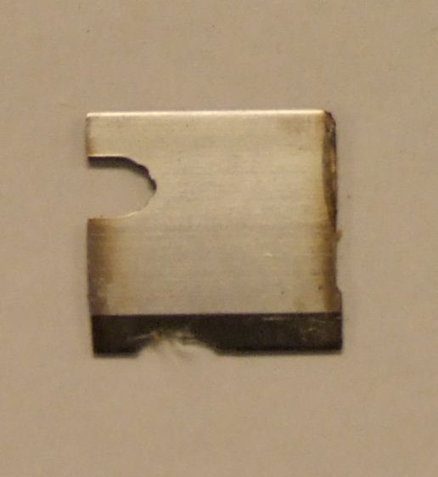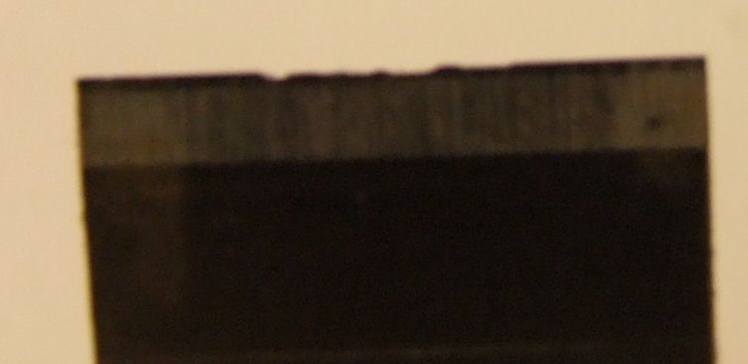

Figure 5. At left is the blade from NA15; at right is the blade from NA28 indicating the chipped edge.

Threshold testing (dry)
Testing was completed to determine the load threshold at which the TTLC devices operate and cause the blade to move forward. A TTLC device was suspended from a forklift, and a low weight was placed in line with the TTLC. Using calipers, the rate at which the TTLC opened was measured.

Table 5. These data indicate how much time is required for the TTLC to move so the line is cut.
Weight | Time | Distance of separation
162 | 5.2 | 0.303”
162 | 6.2 | 0.360”
162 | 6.3 | 0.4”
190 | 9.4 | 0.428”
190 | 11.2 | 0.459”

Caveats/anomalies
Device NA 20 had a static cut time of 8.75 minutes, then, approximately 15 minutes during the repeatability and dynamic testing. This may be due to blade dulling or other damage.
Occasionally, the load chain would twist as it was lowered into the tank, and/or the safety chains would become entangled and support part of the load. This accounts for the differences in test weights during the tests. The TTLC however, operated in an on/off mode of operation. The TTLC operated properly with a load higher than the threshold (150lbs).

Trigger line cutter testing
The TLC was designed to enable full line strength of the line in tension when hauling gear. The TLC attaches to the surface float on the hauling line, directly below the float. The cutter is activated by applying force, approximately 600 pounds, to the under side of the TLC to force movement of the two body halves along an inclined surface. This motion breaks the safety band and enables the cutting blade to sever the line releasing the surface float. The line is then free with no knots or bulky elements to catch, especially in baleen. The device works best when the load is applied in a short time frame.
The key issue in testing the TLC was applying the load in a short period of time. A dropped weight would be ideal. A basic welded structure was fabricated to hold the underside of the TLC while applying the load (Figure 6).
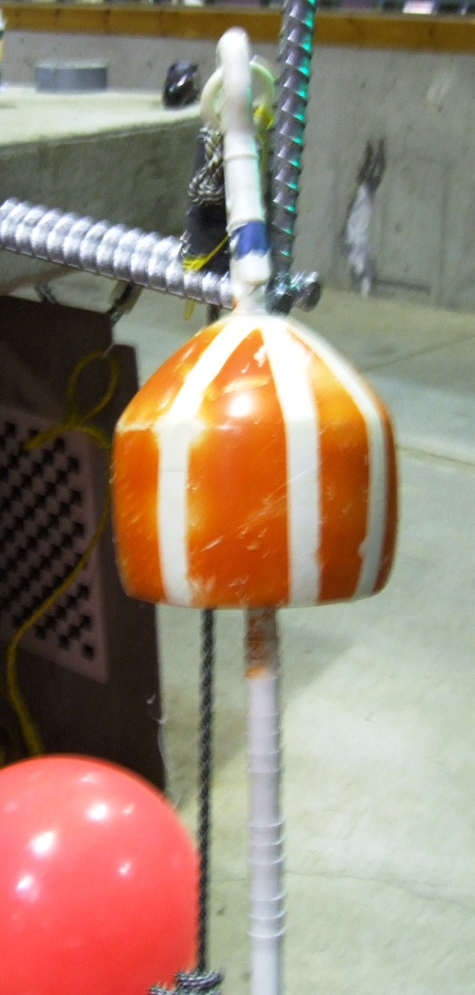
Figure 6. TLC as it was configured for test cut. The silver rebar structure holds the TLC for proper load application direction. The toggle is shown as it would be connected to the TLC.

The difficulty with this configuration was measuring the load-time event and applying the load in short time. Measurement was abandoned in the early tests as there were other concerns with the sacrificial safety bands. The intent was to have these bands fail in shear as the two body halves moved along the inclined plane. If the load was applied slowly, over a period of seconds, then the failure was a long time coming (Figure 7). A variety of tie wraps, bands, were tried. Observation of the bands after these initial tests indicated that the bands were elongating, so an alternative failure mechanism was tried.
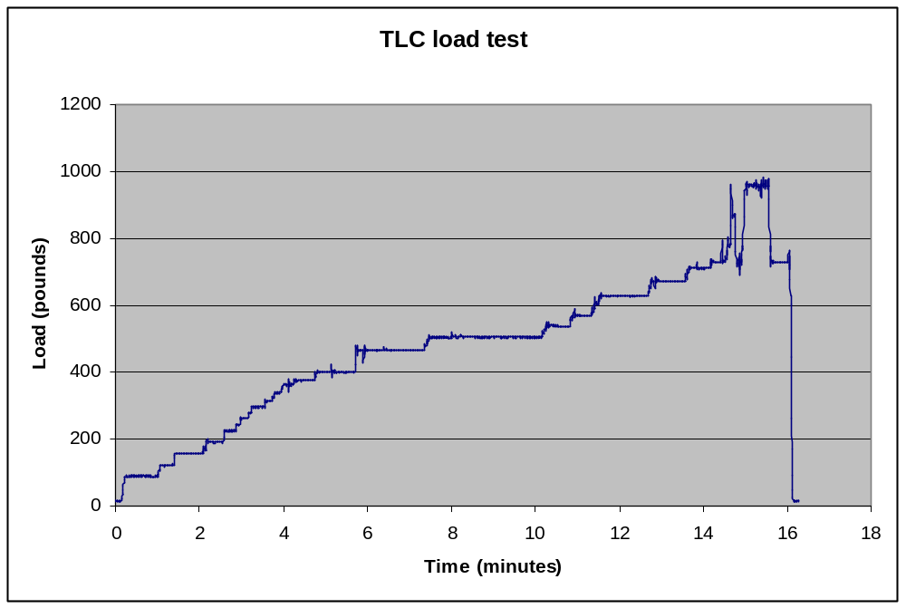

Figure 7. Typical load versus time plot for intended failure mode. Long time frames for loading result in larger loads being applied for failure.

The portion of the band 90˚ around from the original failure zone was purposely whittled to a smaller cross-section. The concept was to have this section fail in tension as the band was elongated when the failure loading was applied. A number of trials were run to investigate this alternative. There was more consistent success. The bands need more investigation to determine the best method of failure for a reliable device. The whittled band and the subsequent loading test result are shown in Figure 8. The time frame for failure was approximately 8 seconds from load application, and a smaller load was required.

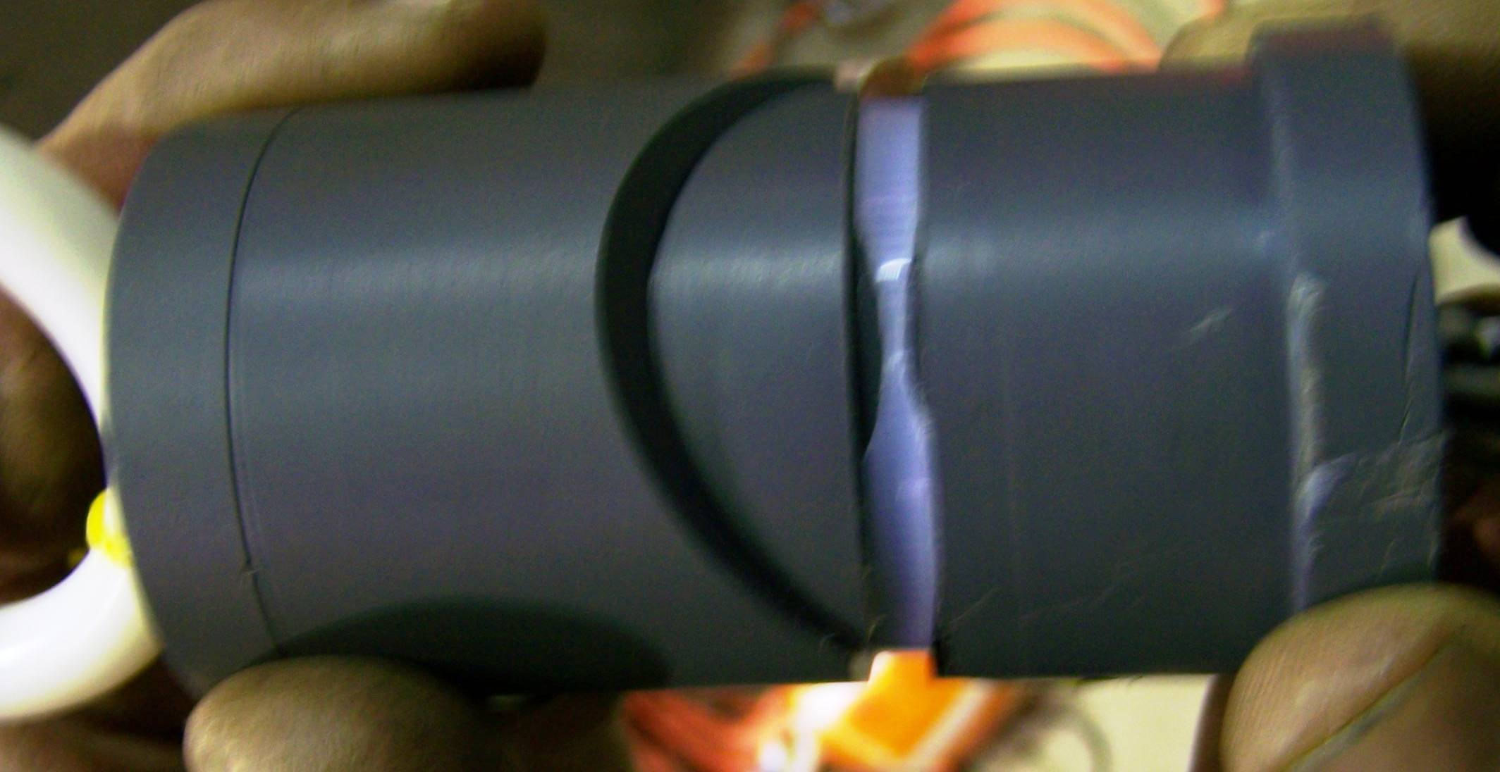

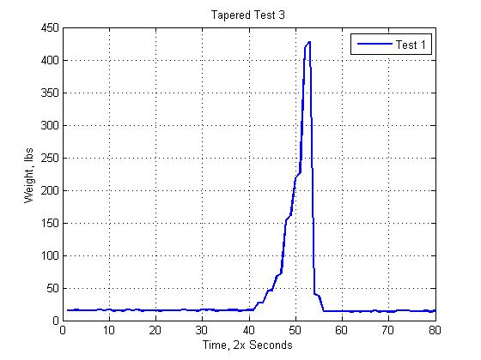
Figure 8. The top photo shows the whittled band in place. The bottom plot indicates a faster time to failure, but not ‘instantaneous’.

To verify the devices were operational, the trigger devices were subjected to an impact load, the shortest loading time. The trigger device was placed into a vise, and the flat part of the trigger was struck flush against this surface with a rubber mallet. The strike was considered “weak”, that is the tester simply let the weight of his arm bring the mallet down. Three tests showed that under these circumstances, the trigger device tie wraps snapped easily. There were no measurements made during these tests.
The summary of these tests on the TTLC and the TLC indicate that these two devices are capable of their intentions. The TTLC are further along in their development. The TLC needs more research on the safety bands material and failure mechanism. Appendix A has all the TTLC results and Appendix B has all the TLC results.

Task 1: Full Scale NARW flipper
The objective of this task was to develop a full scale mode of a NARW flipper and adjacent body. The shell of the flipper was completed earlier and the adjacent body section was designed. The component which was missing was how to deploy the assembly and run it into various gear and lines. After many discussions with Ben Brickett of Whale Safe Gear Ltd the concept of deploying the flipper assembly from a small lobster boat outfitted to accomplish this task moved forward.
The Jesse B was outfitted with the necessary attachment fixture in the keel and along the rail to accommodate the whale-flipper frame. The frame was designed to be deployed amidships, along the starboard side and to enable subsurface deployment of the whale-flipper structure. Whale Safe Gear, Ltd. performed the frame fabrication in consultation with UNH/OE. The final fabrication of the whale-flipper attachment to the frame was subsequently fabricated. Initial testing of the frame on the Jesse B, load cell deployment strategy and field site selection were all completed by Whale Safe Gear, Ltd. The initial testing of the frame was all qualitative and observational. Quantitative evaluation is scheduled for the next funding cycle.
The whale-flipper assembly was fabricated at UNH/OE. The basic flipper was fabricated earlier. Acquiring size data for the flipper required trips to a museum in St. John, New Brunswick, using a tracing of a flipper from a stranding on a plastic drop cloth, and the best information gleaned from whale photos. All these data were then utilized to develop a flipper utilizing a computer program from the ship designing arena. The whale body was the final component, which could only be designed after the deployment scheme was decided. The role of the whale body component is to provide proper geometry and a base for deploying the flipper. How the flipper ‘fits’ into the whale is important. Control of the front-back and subsequently the up-down articulation is important when performing tests of the whale flipper and line / gear interaction with a vertical line.
The whale body component is a steel frame structure with a shell fabricated from steel lath mesh and fiberglass. The contour of the shell-body side was acquired from the data used to fabricate a 1/8 scale model of a NARW model (McRae, Lewis, and McMicken 2005). Representative ribs were fabricated from plywood and poplar and used to finish the steel frame structure. The steel lath mesh was then added to provide backing for the fiberglass. Two layers of 12 oz. fiberglass and ample resin were then applied. The result is a solid structure for applying the finish.
The flipper needs to be installed into the whale body and fastened. The entire structure will then be covered with approximately 1” of neoprene rubber and a 1/8” harder rubber outer cover. This is a more arduous task than it appears to be. It is necessary to have the forward transition from whale body to flipper be “seamless”. When one considers the complexity of two contoured surfaces intersecting approximately perpendicular to each other, coupled with the need to have movement, then the difficulty is apparent.
Before this final assembly could happen there was one other detail requiring consideration. The flipper in the hollow, neoprene covered condition would be approximately 400 – 500 pounds buoyant. After investigating a variety of ballasting materials it was decided to use concrete. The approximate density of the concrete necessary, due to the volume available in the flipper, was not a standard density. The students in the Civil Engineering concrete design course at UNH developed a concrete with a density of 125 pounds/ft³ for this purpose. The flipper was subsequently filled with this concrete. At this writing all the materials and components for completing this whale-flipper assembly are in place and partially assembled.
The following set of figures show the various components in the whale-flipper assembly. Final assembly will require a short time and then the entire assembly will be lowered into the large tank at the Chase OE Laboratory for overall buoyancy determination.
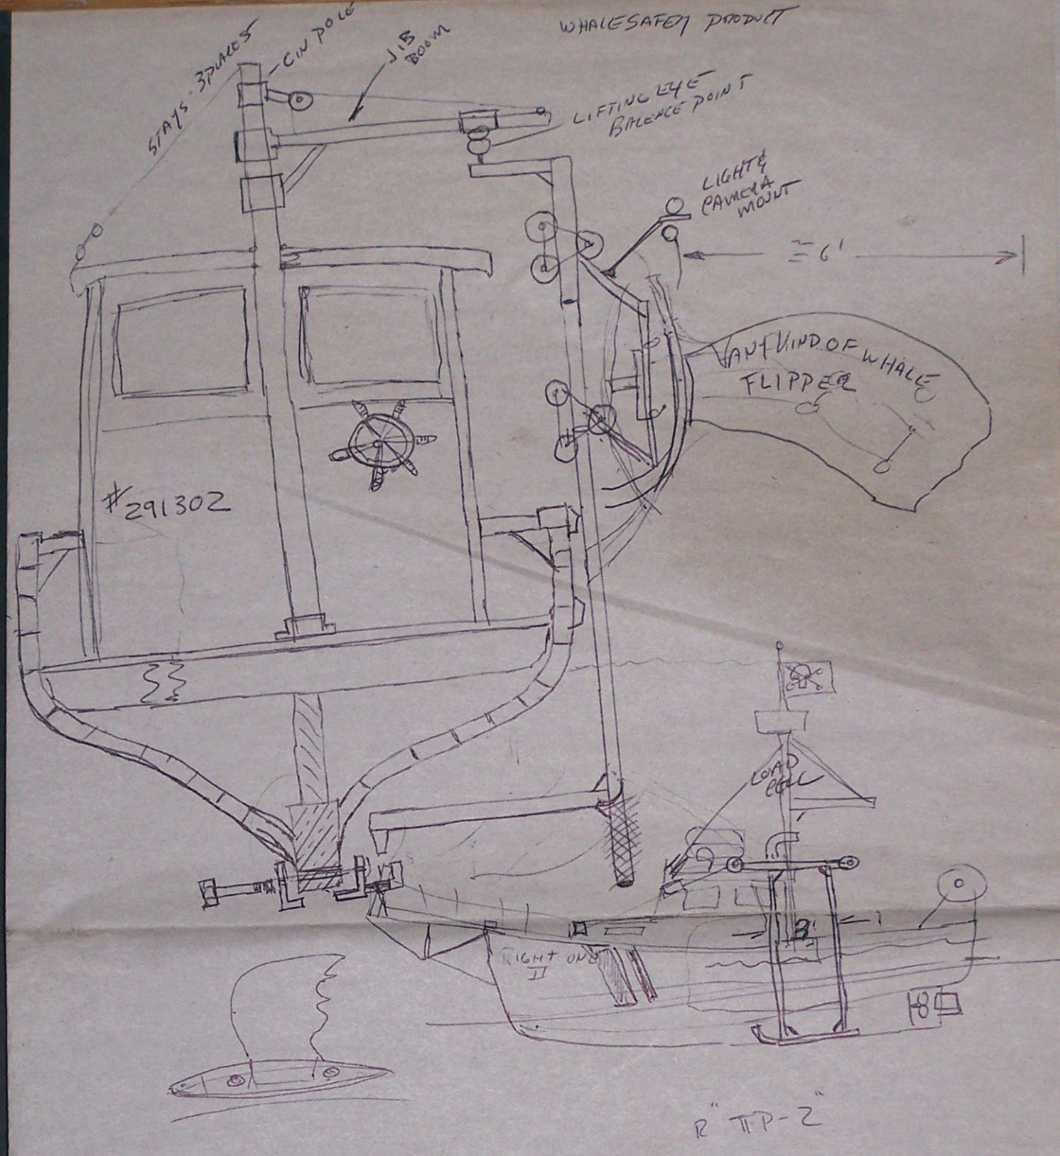
Figure 9. Sketch of the Jesse B. The beginnings of the development of the testing system are shown in this sketch by Ben Brickett after discussions with K. Baldwin.

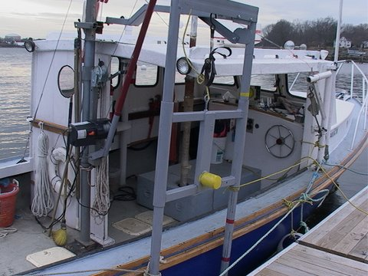
Figure 10. The frame attached to the Jesse B. The yellow lug is the attachment point for whale-flipper assembly. This piece is then lowered into the water (photo courtesy Ben Brickett).
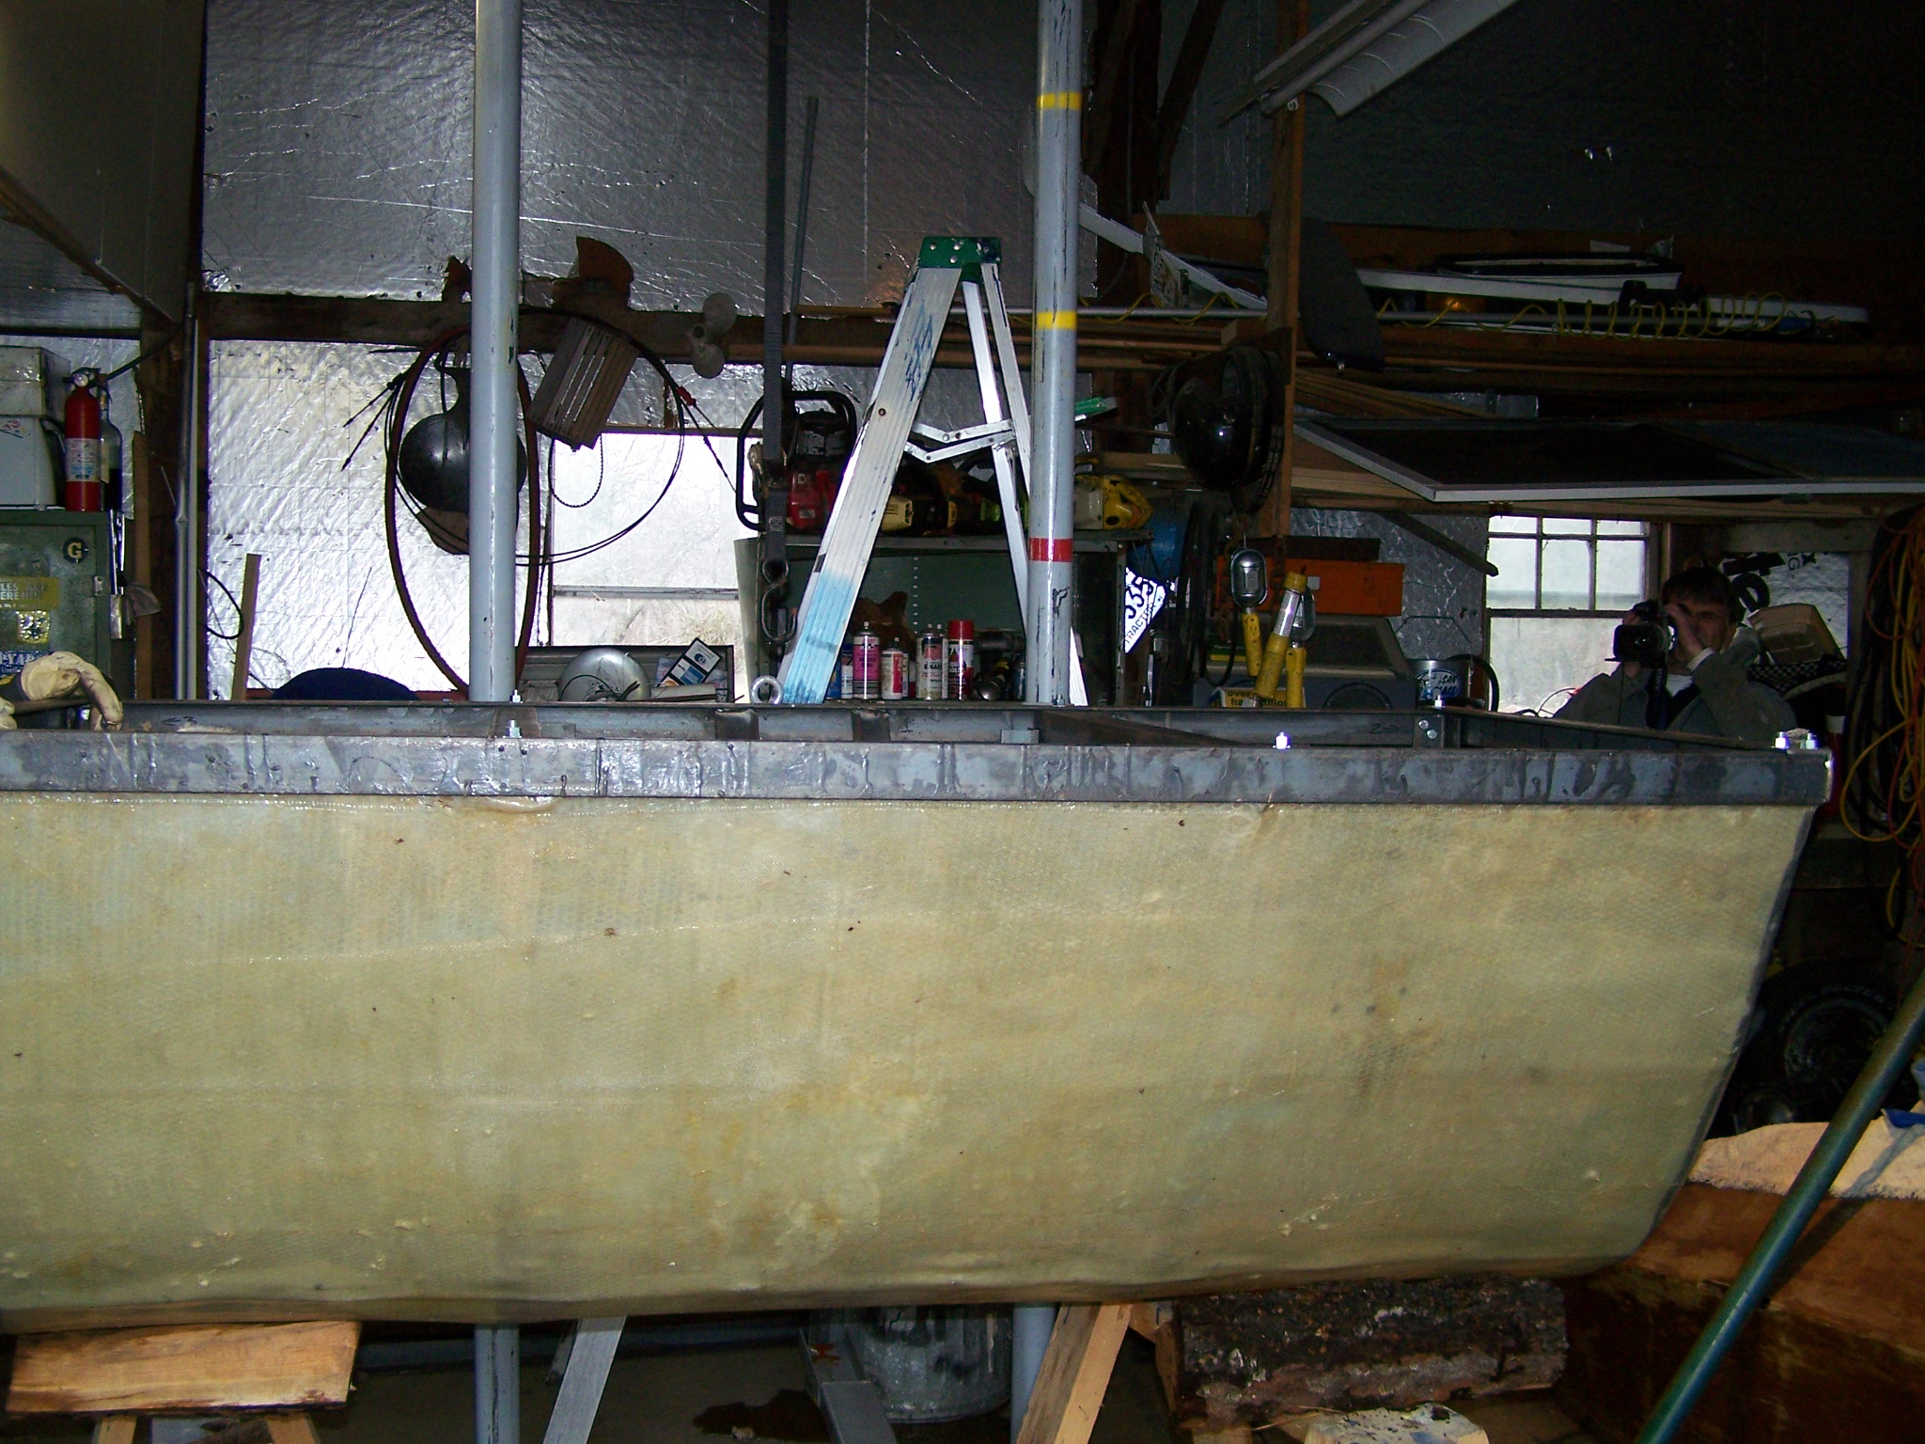
Figure 11. The whale body component and frame as they would be on the Jesse B.

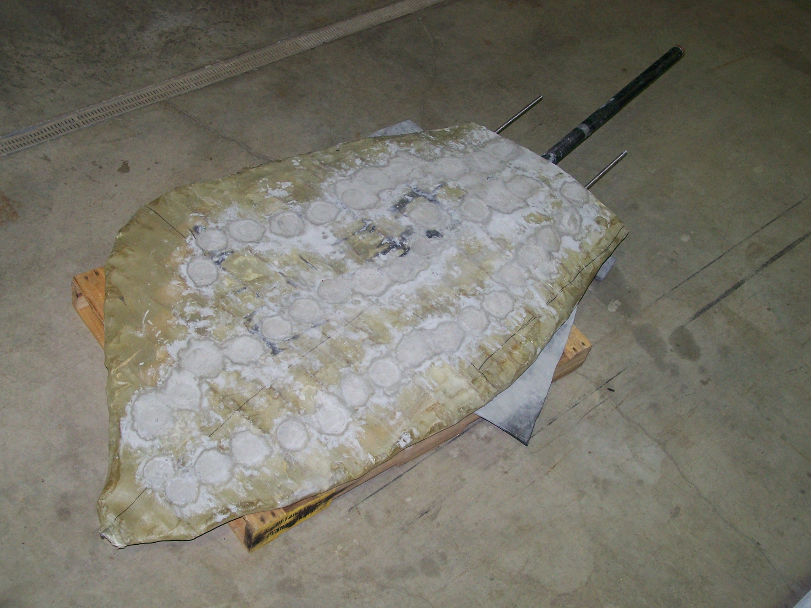
Figure 12. The flipper after the ballast concrete was in place. The pipe fits into the articulating mechanism in the whale component.
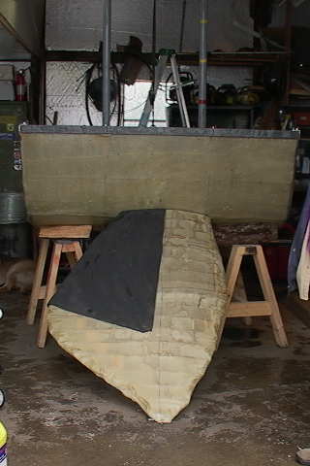
Figure 13. Whale flipper frame assembly as it would be deployed on the Jesse B.
Task 2: Whale safe rope evaluation
The rope testing apparatus developed by McGillicuddy (2005) was scheduled for an upgrade in the elongation – optical measurement system. Preliminary work to identify a camera with ample resolution to capture the entire elongation with a single camera was done and a new camera was acquired. There are discussions pending with the Consortium about the best approach for moving this effort forward.

Task 3: Scale model whale-fishing gear interaction
The 1/8 scale model NARW was repaired in late Spring 2006. These repairs were necessary due to the damage done during the initial testing by the student project group. The next step was to have the model rotate as it was being driven forward into vertical lines. Concepts were discussed and some very preliminary work was done. There are some details which need consideration if this task moves forward. The method of rotating the whale model needs to be finalized and the string used as vertical line needs to be reconsidered. One interesting aspect of the initial testing was the string used as scaled down vertical line cut into the flipper neoprene when the interaction happened. This was probably due to the compliance of the neoprene, the tension which developed in the mono-filament and the diameter of the mono-filament. It might be useful to use a string diameter which is not scaled down exactly which would reduce the potential for the ‘line’ to cut into the neoprene. Using a larger diameter line would reduce the stress on the neoprene which would reduce the potential for cutting into the neoprene.
Summary
The focus of the work reported here was mainly on testing the TTLC and TLC devices. The TTLC testing was accomplished after a few alterations to the testing method. The results of the TTLC testing indicate that these devices have great promise for in situ cutting of fishing gear lines during the entanglement process. The TTLC cut the line under constant tension within reasonable time compared to the prescribed time. The simulated dynamic testing, load increases followed by load decreases, produced results which indicated the accumulation characteristic of these devices. The final testing at lowered temperature yielded longer times to cut. This is an artifact of the increased viscosity of the oil used in the TTLC.
The TLC needs more attention only in the band selection. The initial concept was to have the band fail at the intersections of the band and the inclined plane. This concept worked well in dry tests with impulsive type loads. If the loading was ‘slower’ as was the case in the tank then the band began to stretch at the intersection of the band and the inclined plane and the device never cut the line, even at high loads. Experimenting with the bands and notching them to have a smaller cross-section half way between the intersecting points of the band and the inclined plane resulted in placing this weak section in tension. The band failed at lower loads and did not require impact type loads. A new band which incorporates a smaller cross-section as described above is necessary.
The full scale whale body section-flipper structure is near completion at this writing. This is a unique approach to addressing questions about line-appendage interaction. There is no scaling in this approach; real lines with real gear deployed on real bottom will provide some interesting data
References

Characterization of weak rope through the design and construction of a portable tension testing machine, McGillcuddy, Glen, 2005, MSOE Thesis, UNH.

North Atlantic Right Whale: Designing a 1/8 scale model, McRae, H., Lewis, D, and McMickem, R., 2005, Technical Report for TECH 797, Undergraduate Ocean Research Projects course at UNH.

Appendix A. TTLC data

The following plots are load vs. time for all the TTLC testing. The horizontal axis is actually the number of the data points sampled by the A/D converter. The A/D was sampling at 2Hz, or two samples per second. Hence in the first plot the time is 3 minutes and 40 seconds, or 220 seconds, which translates to 440 data points which are indicated on the time axis.
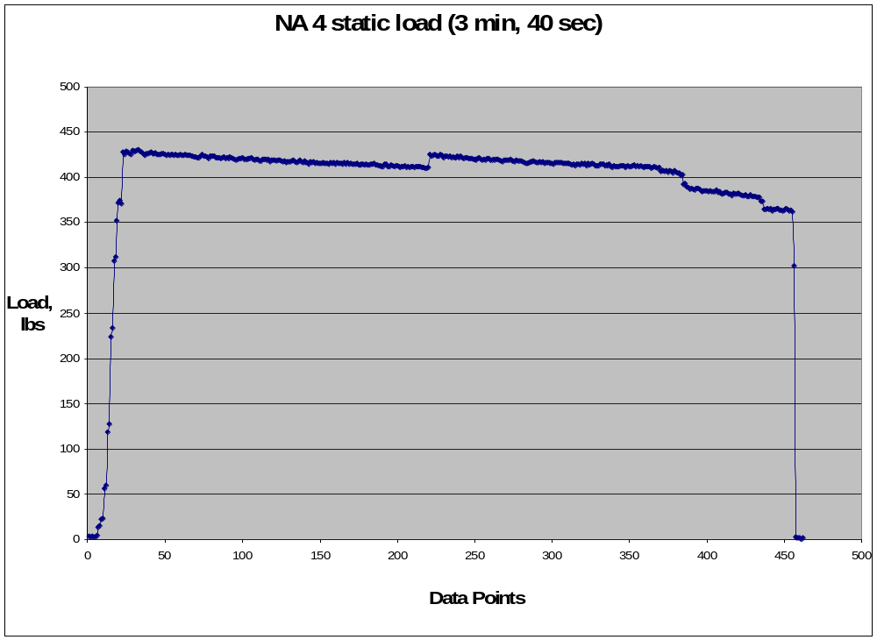
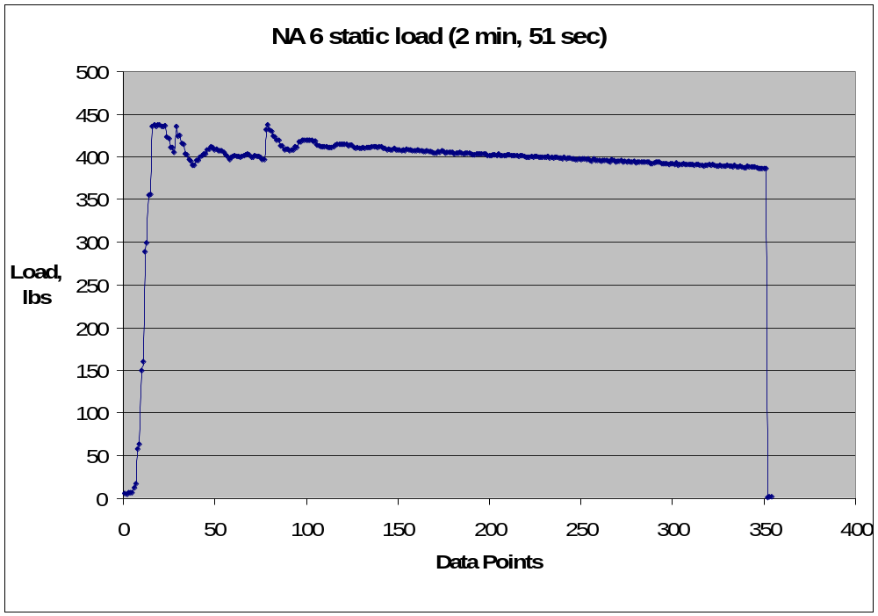
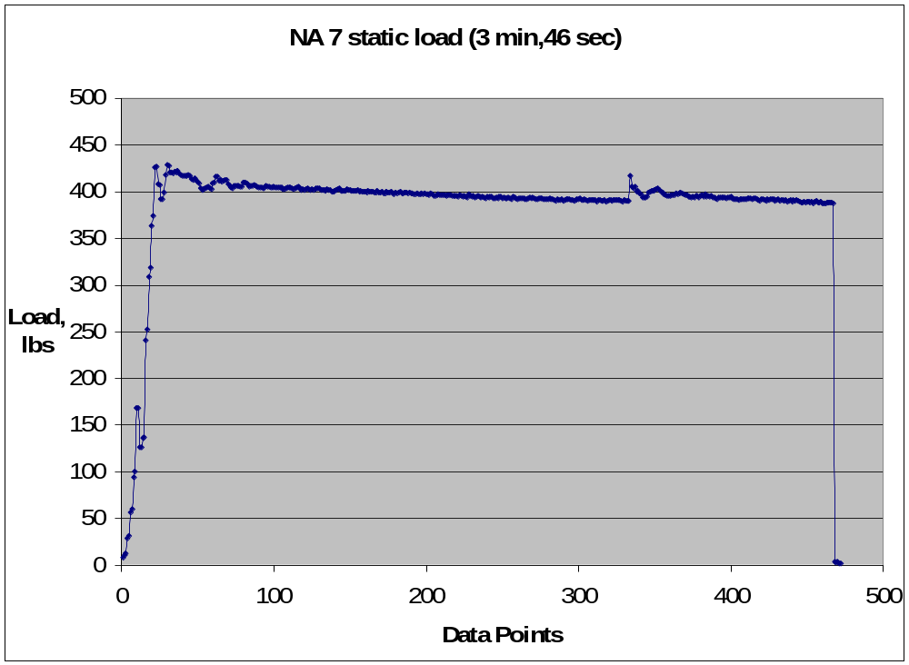
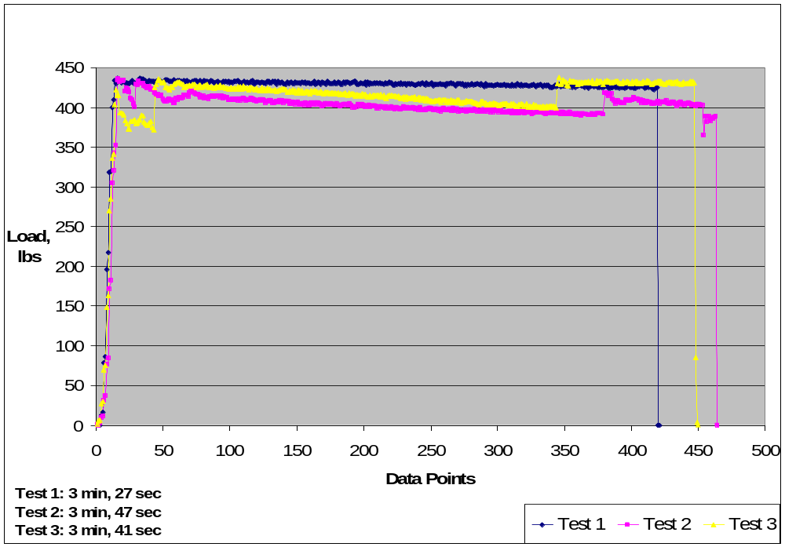
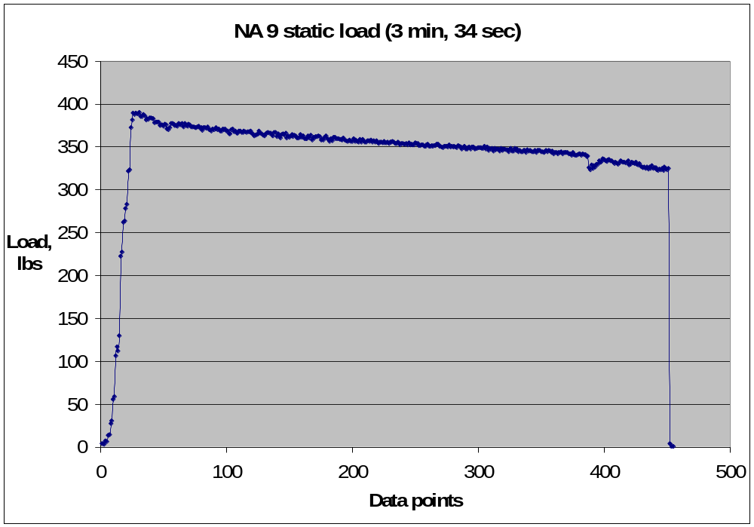
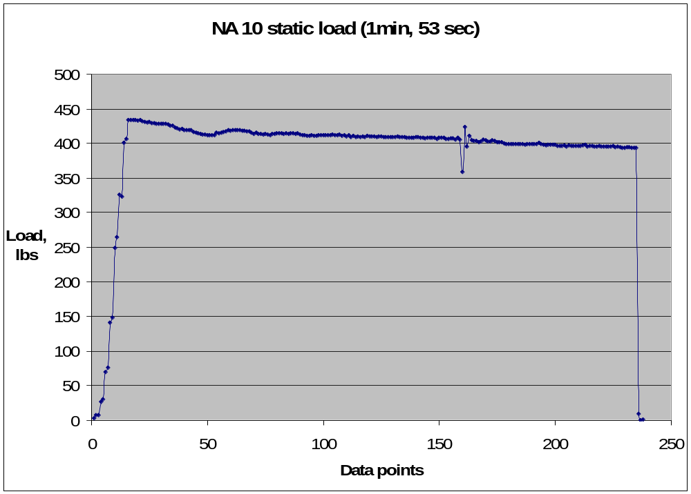
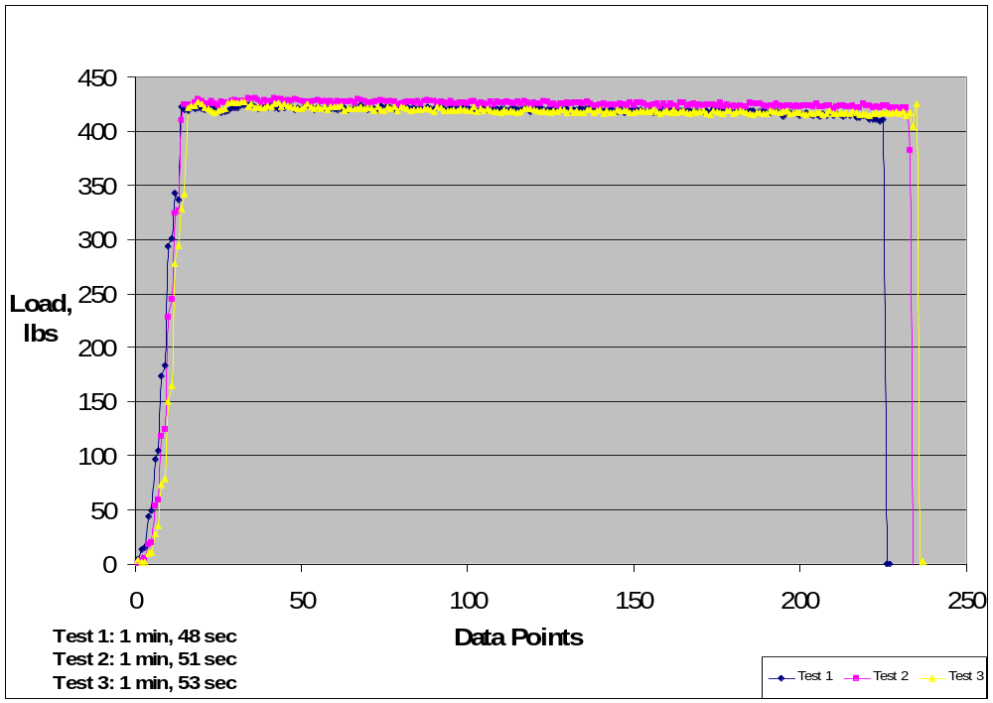
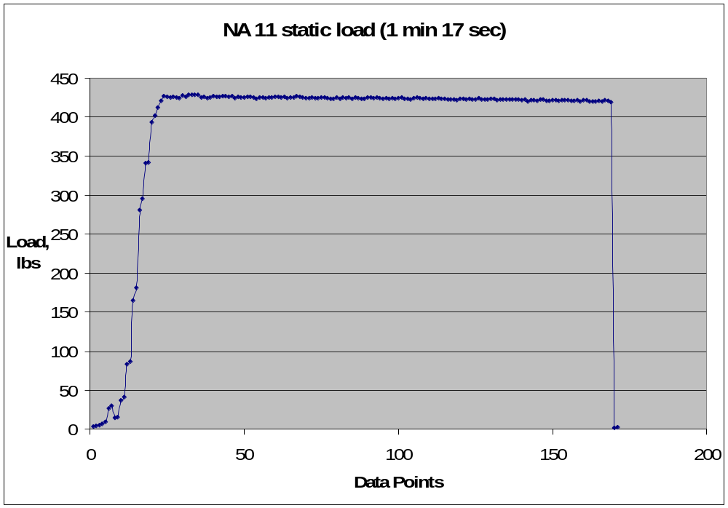
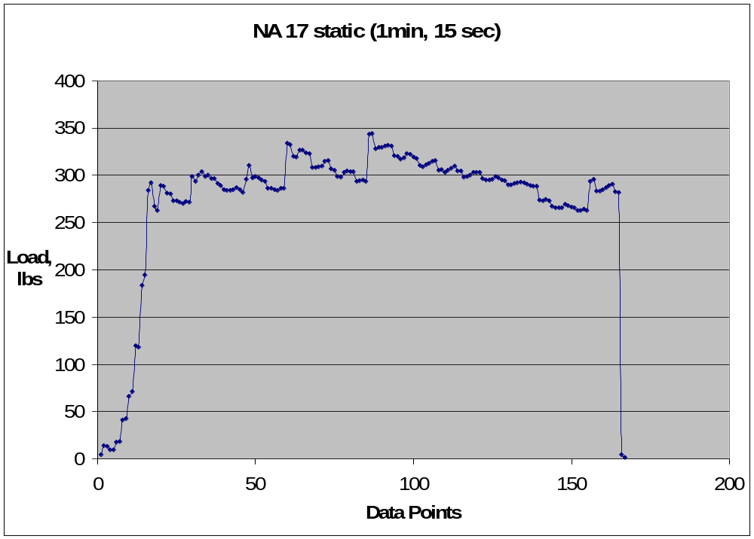
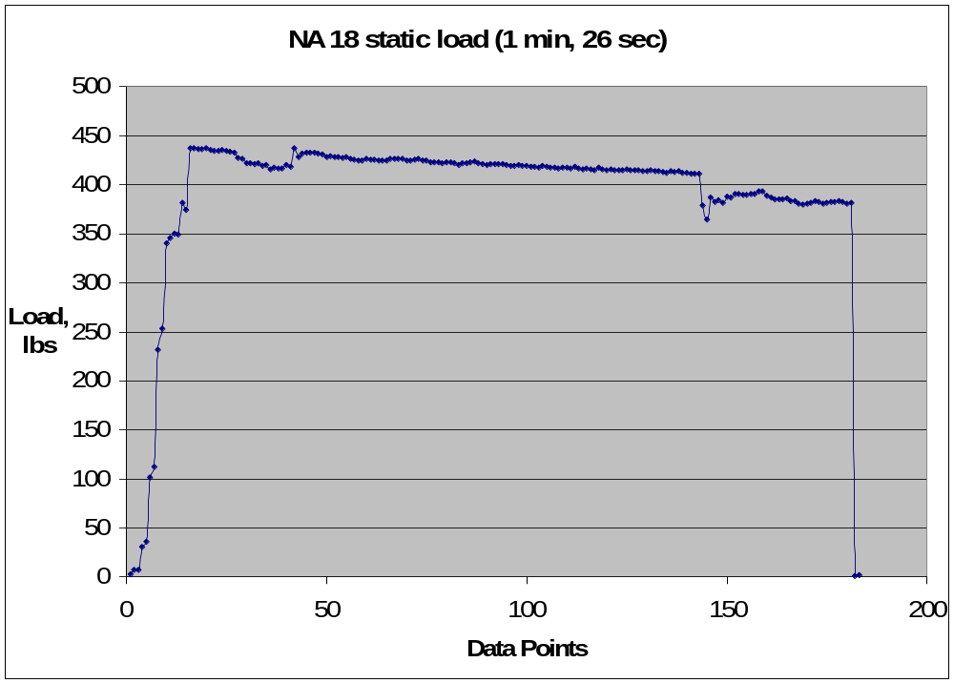
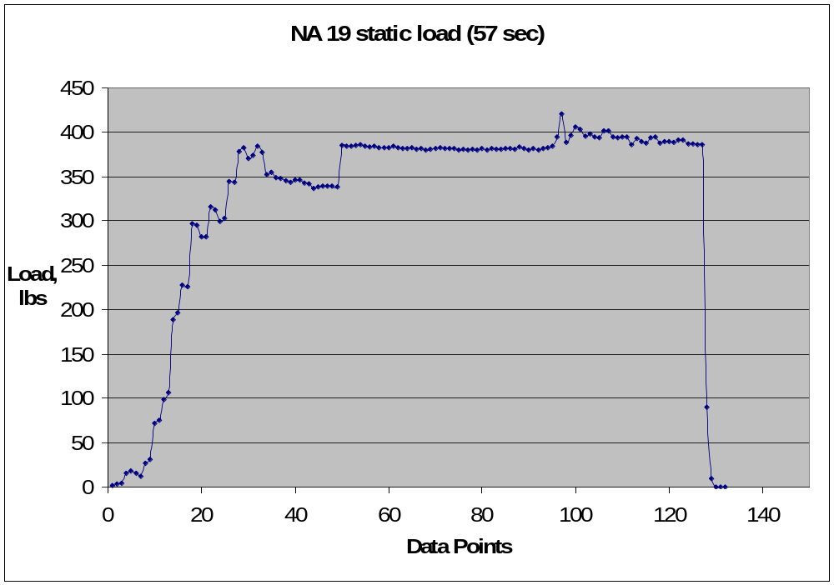
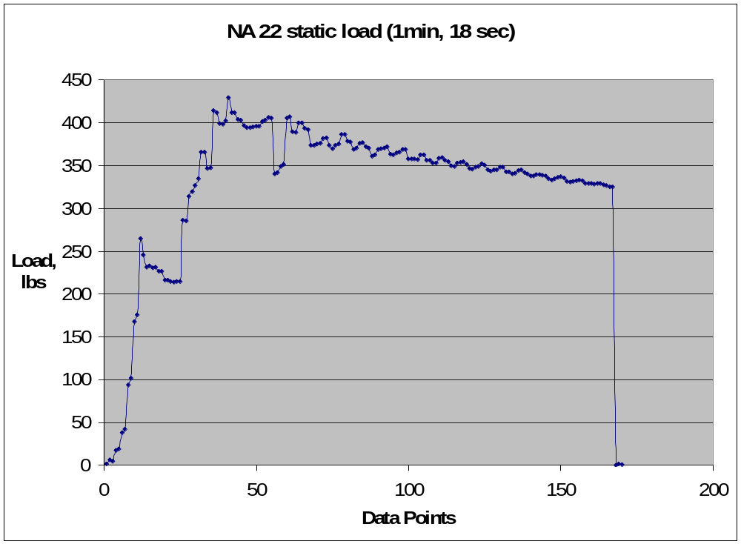
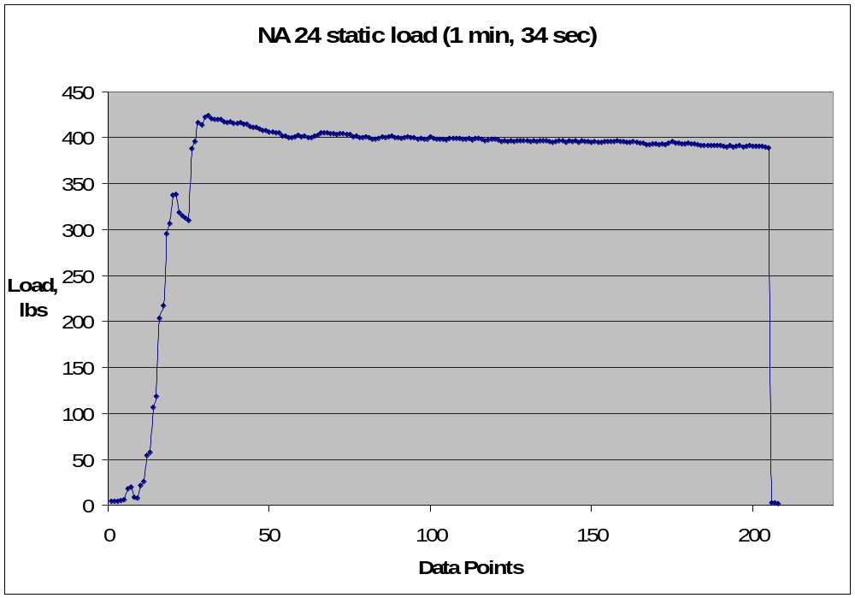
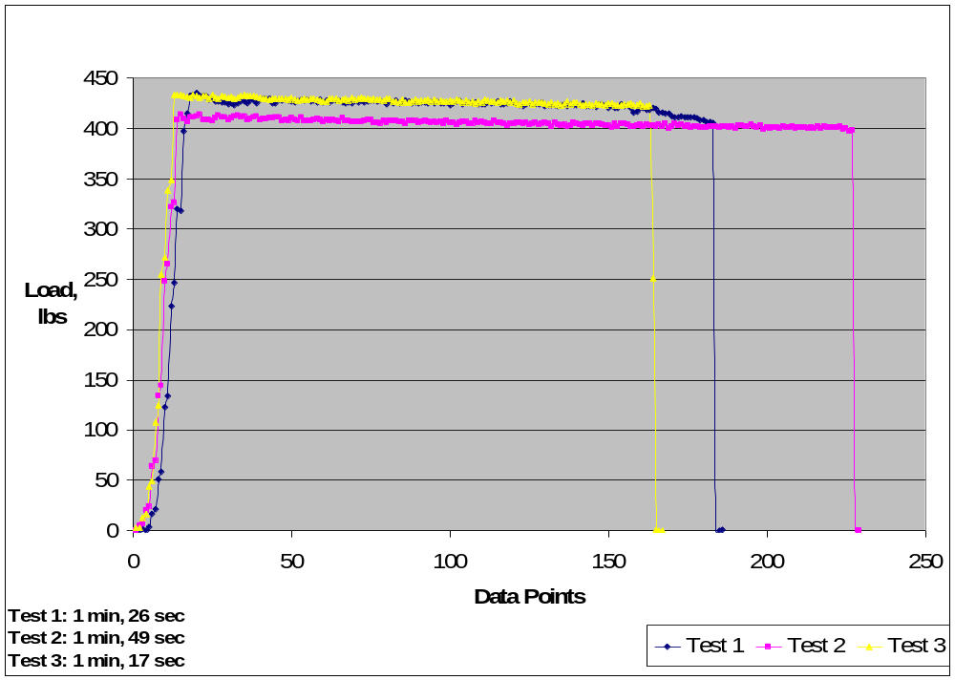
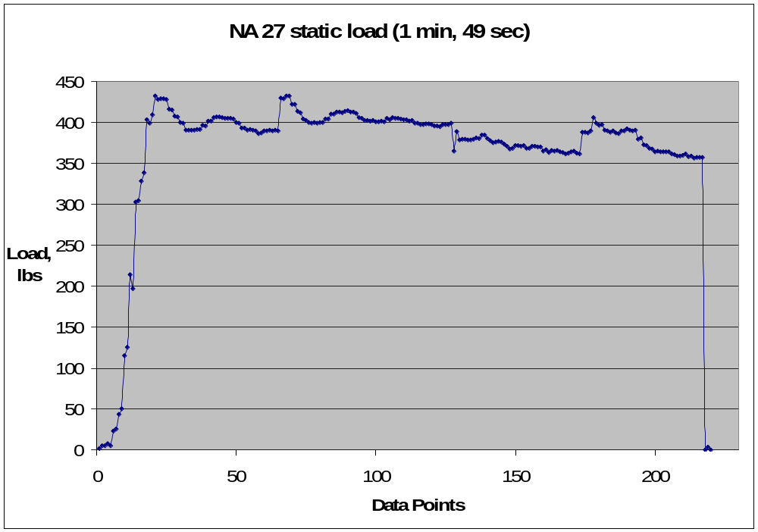
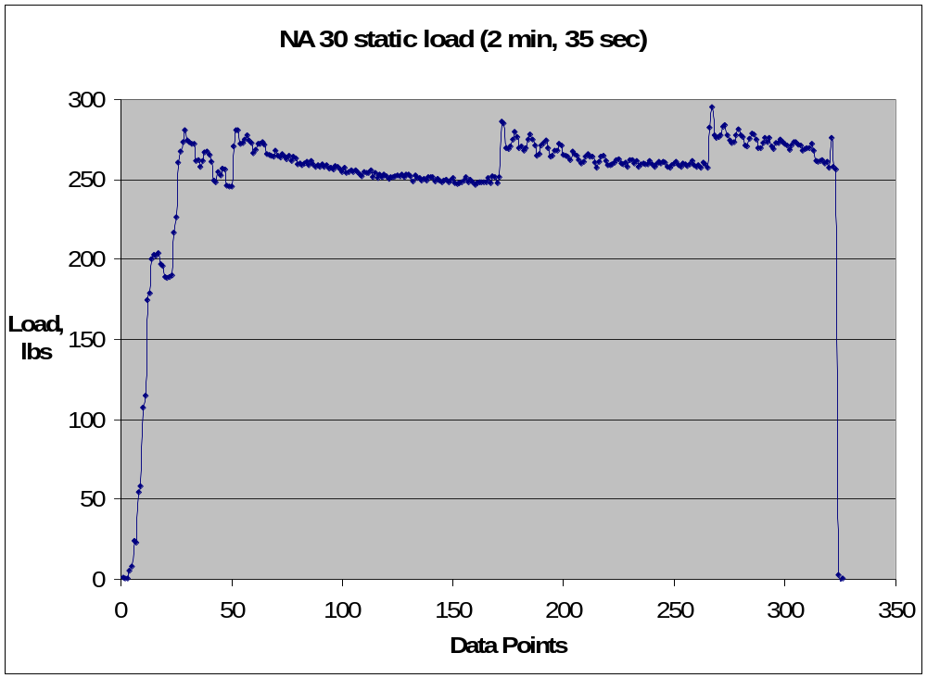
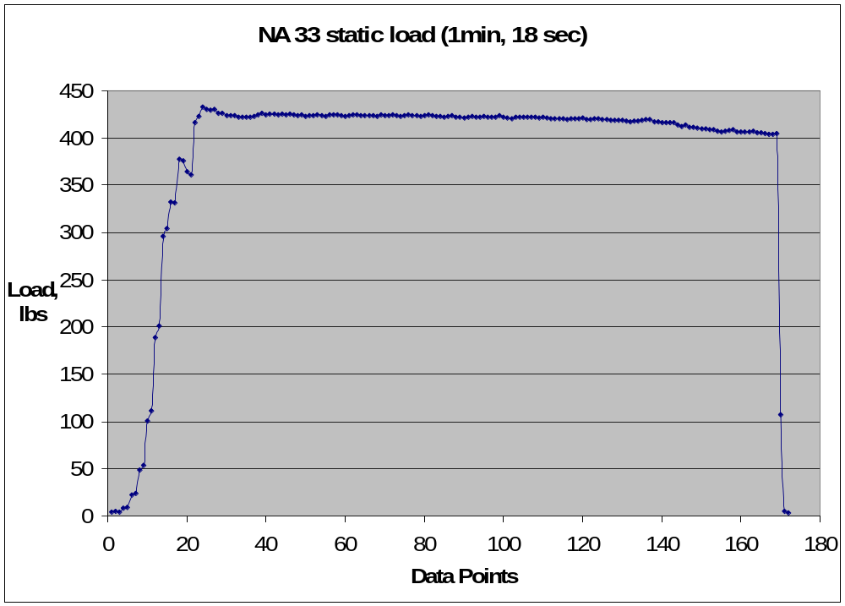
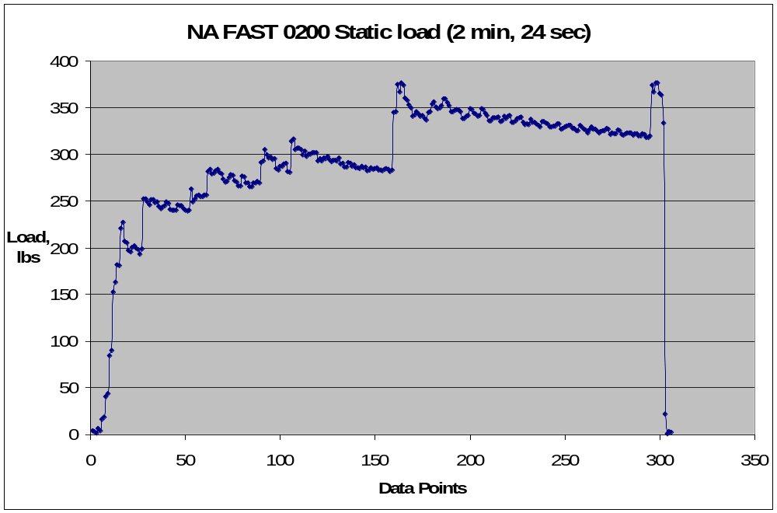
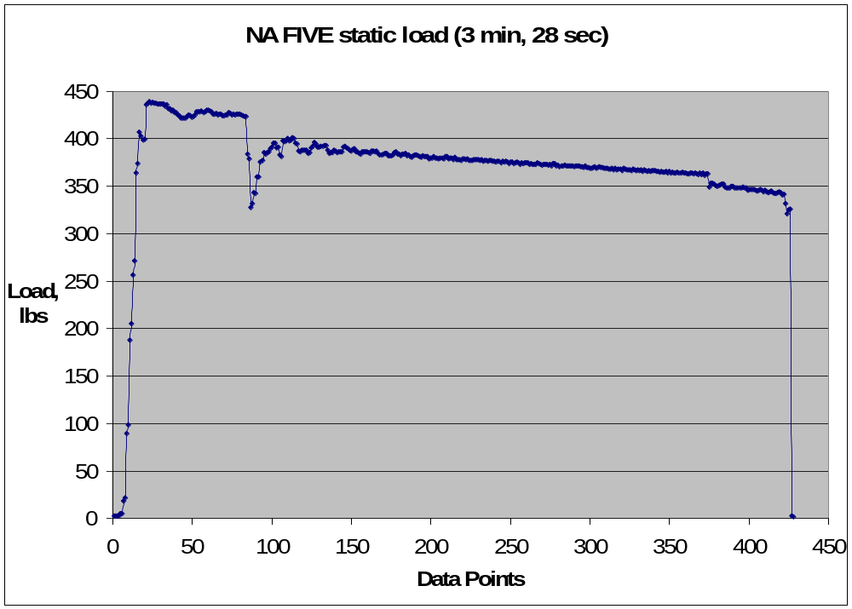
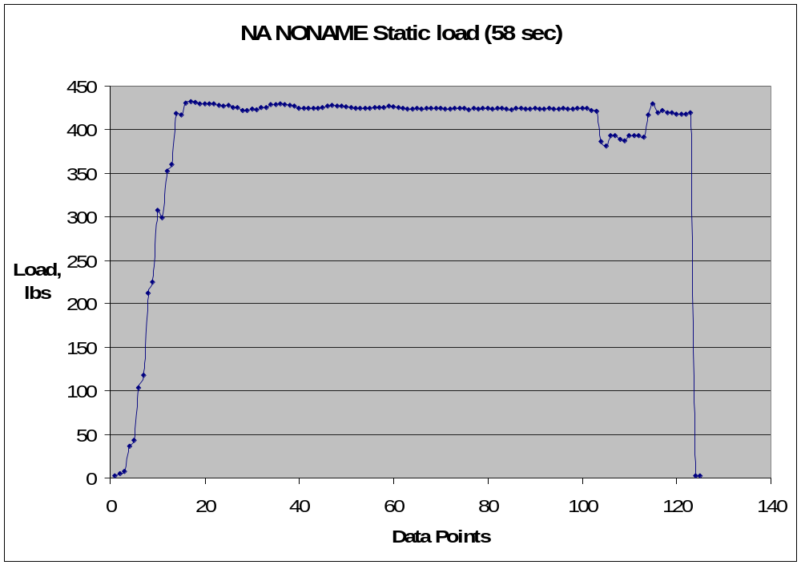
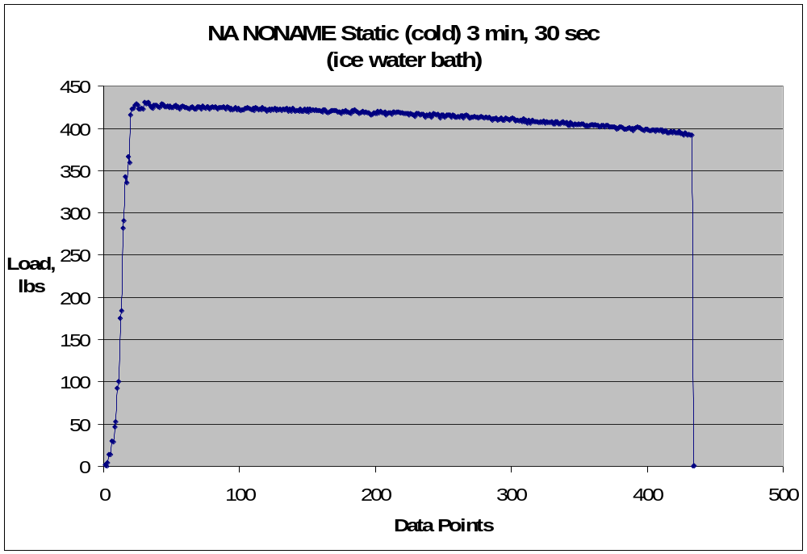
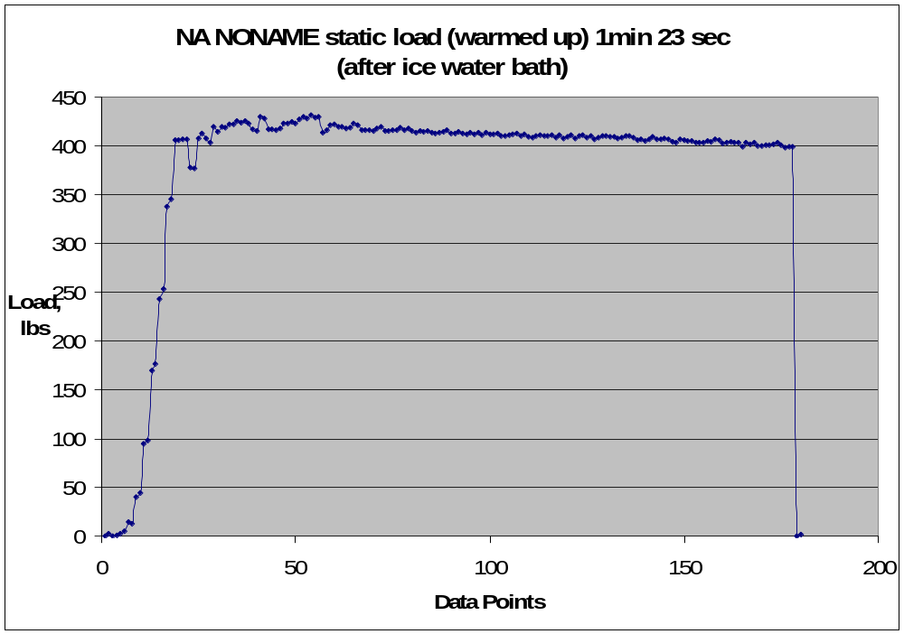
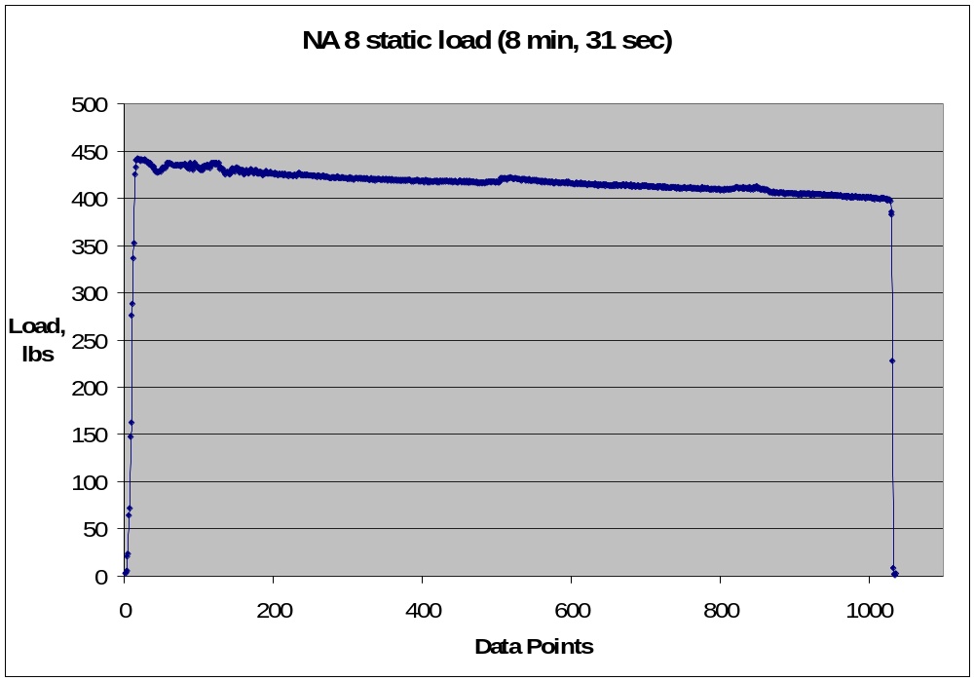
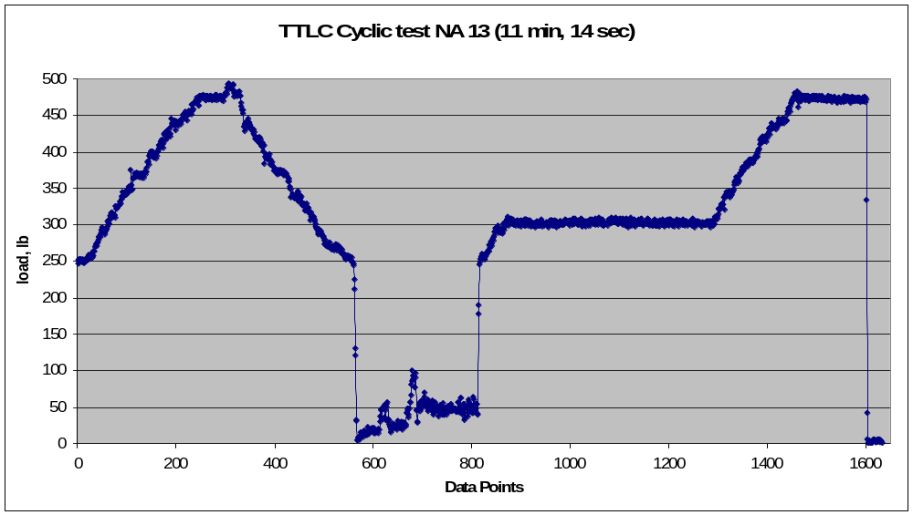

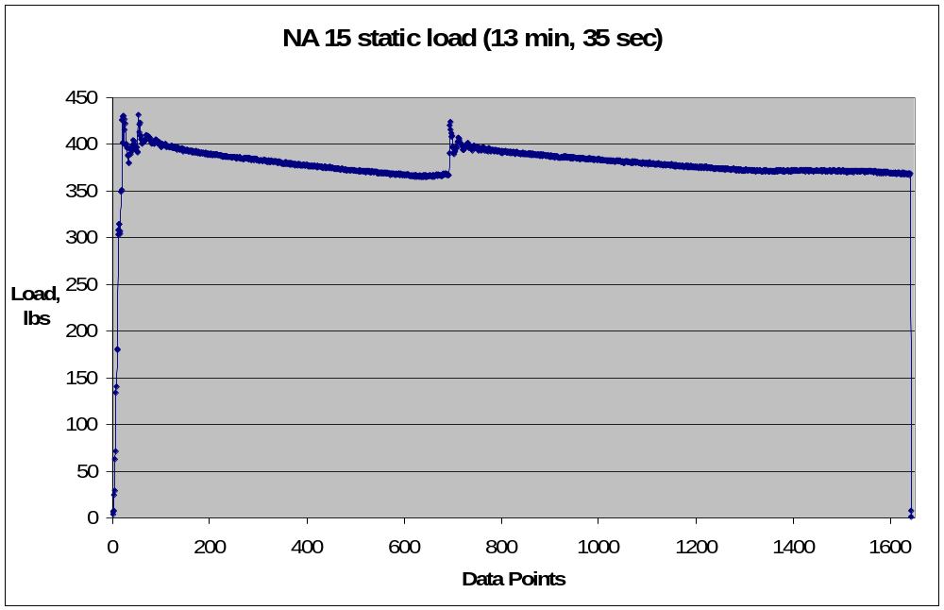
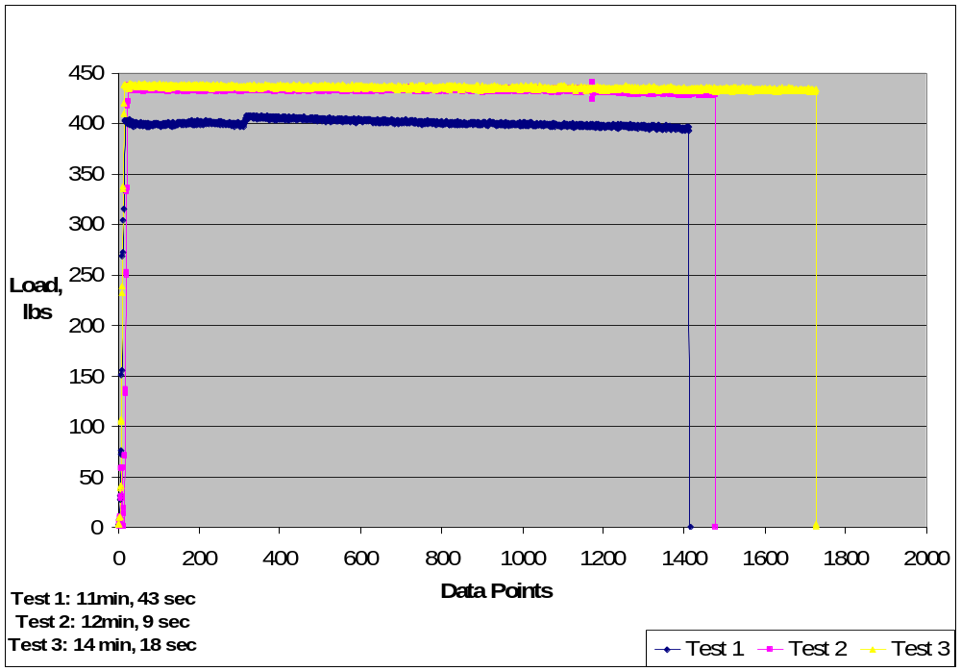
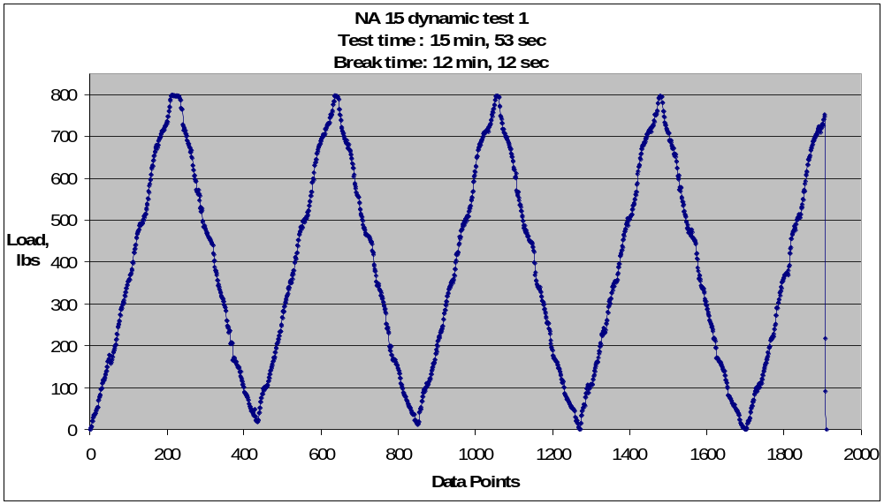
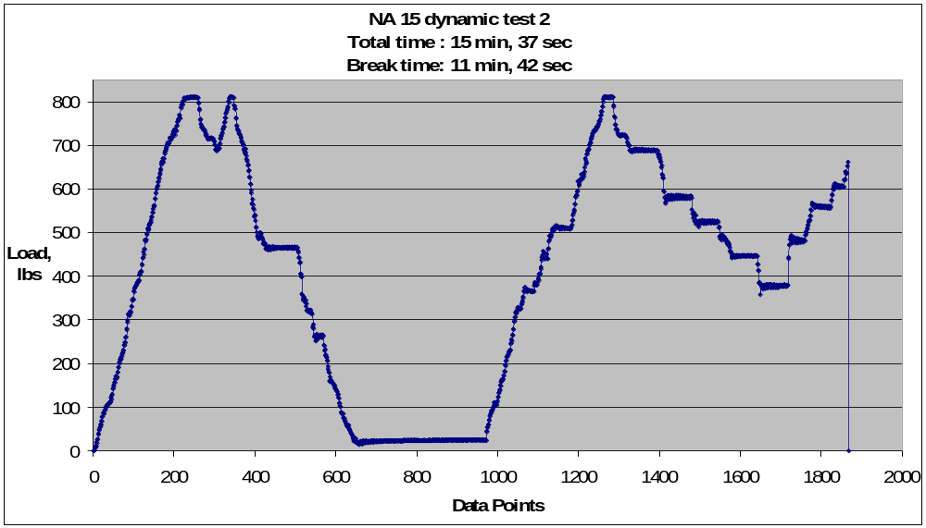
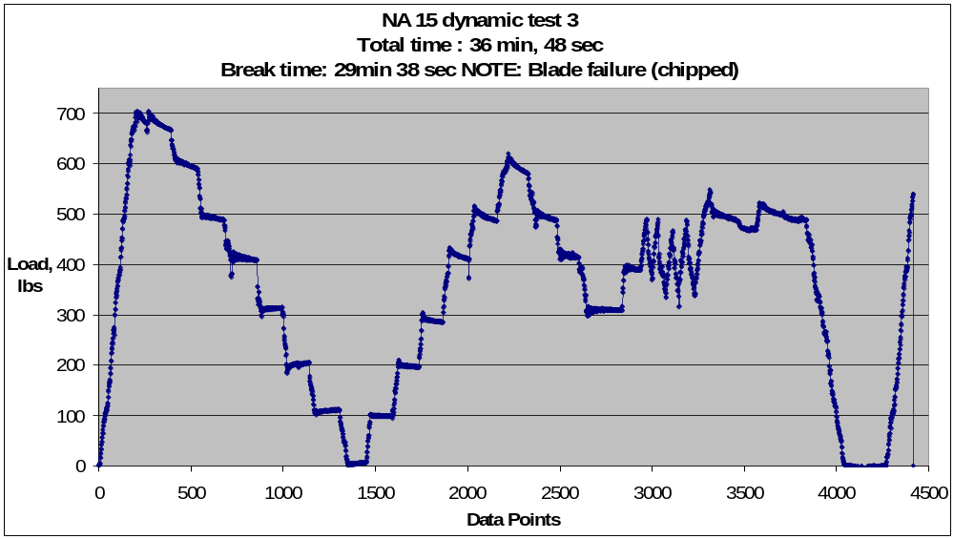
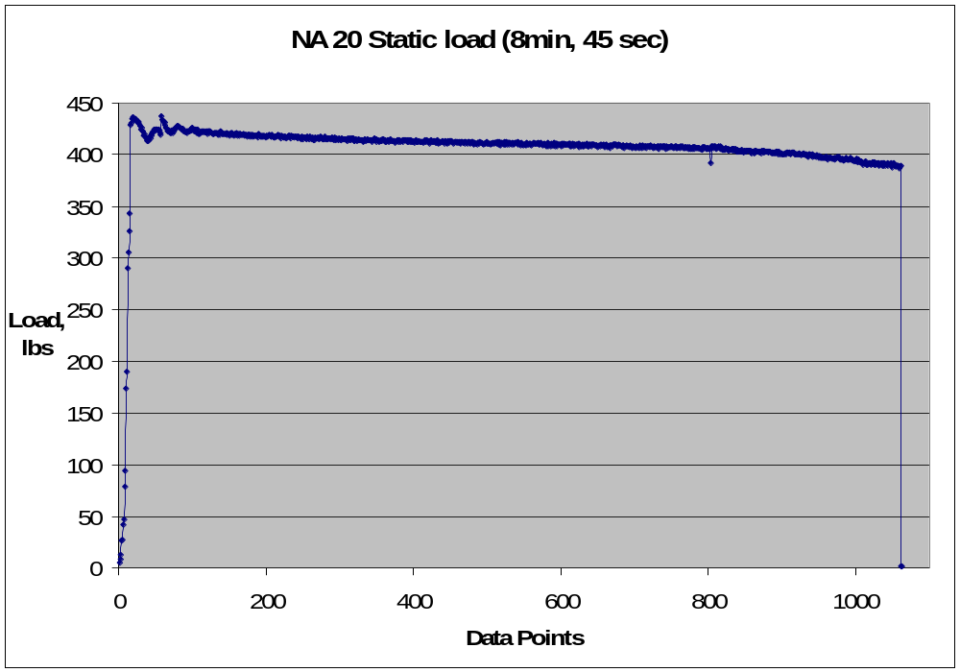
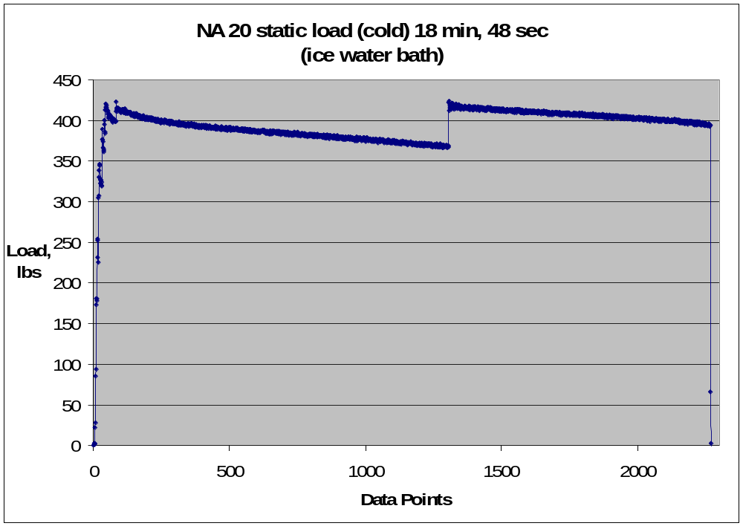
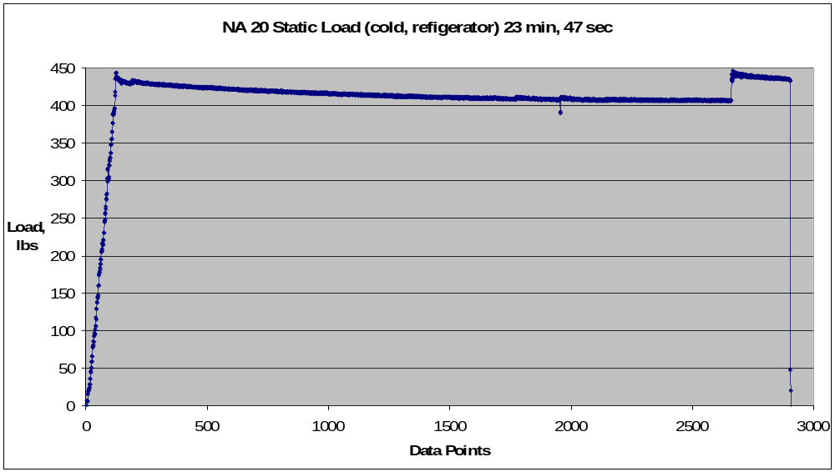

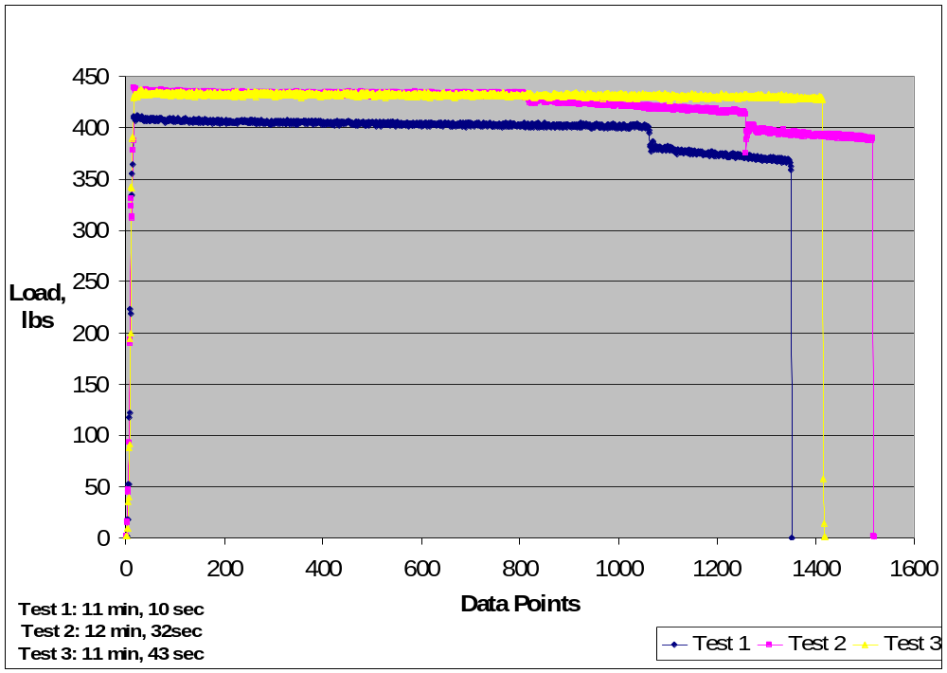
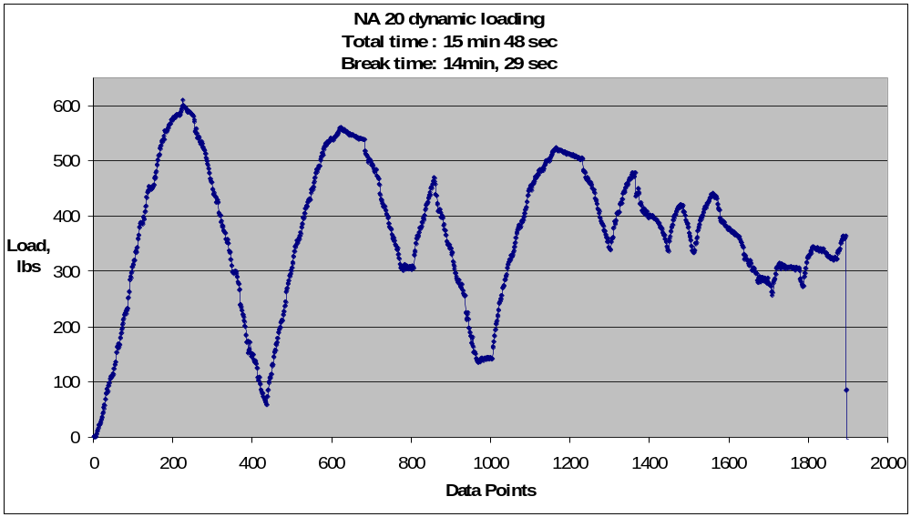

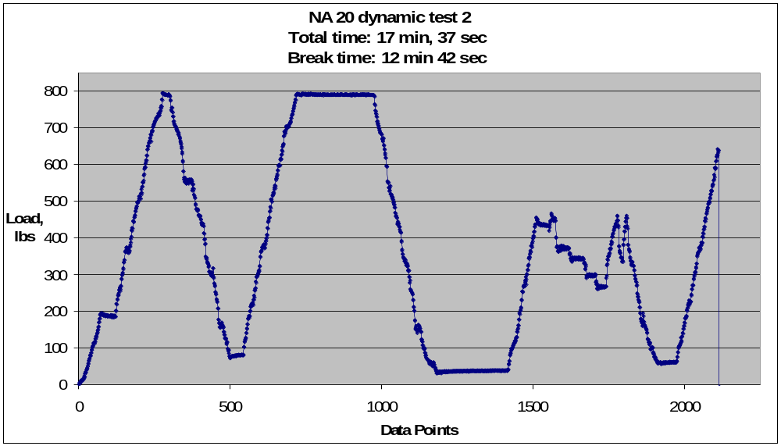

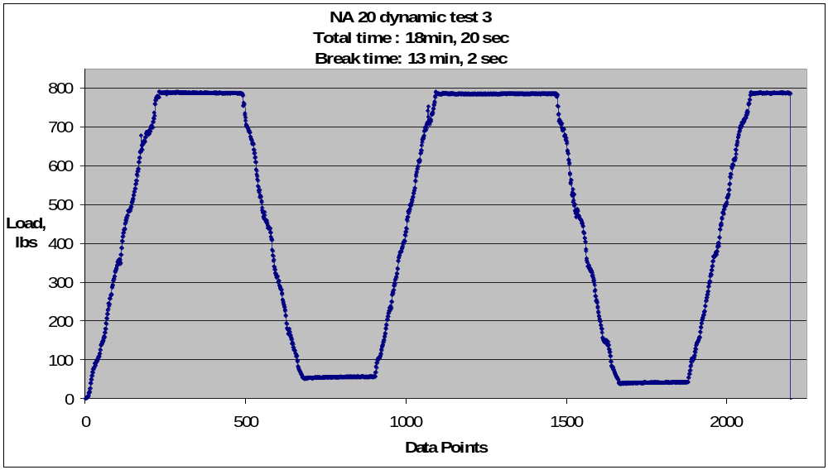

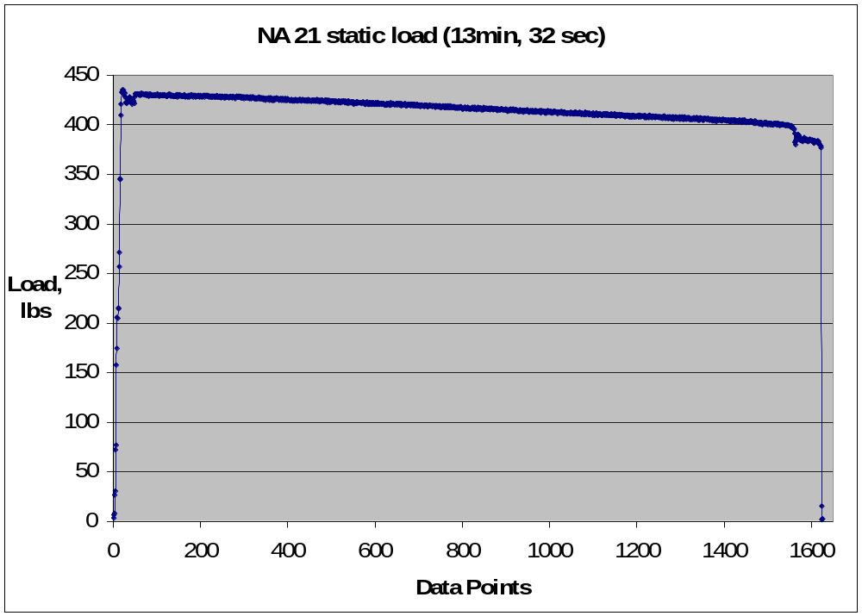
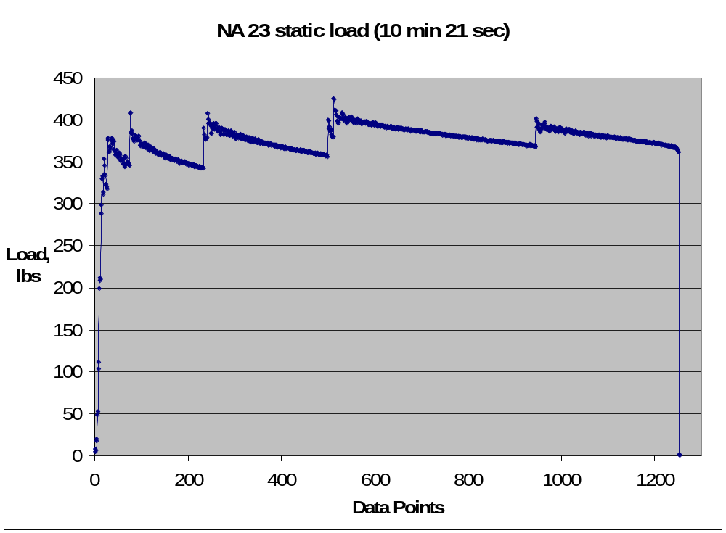
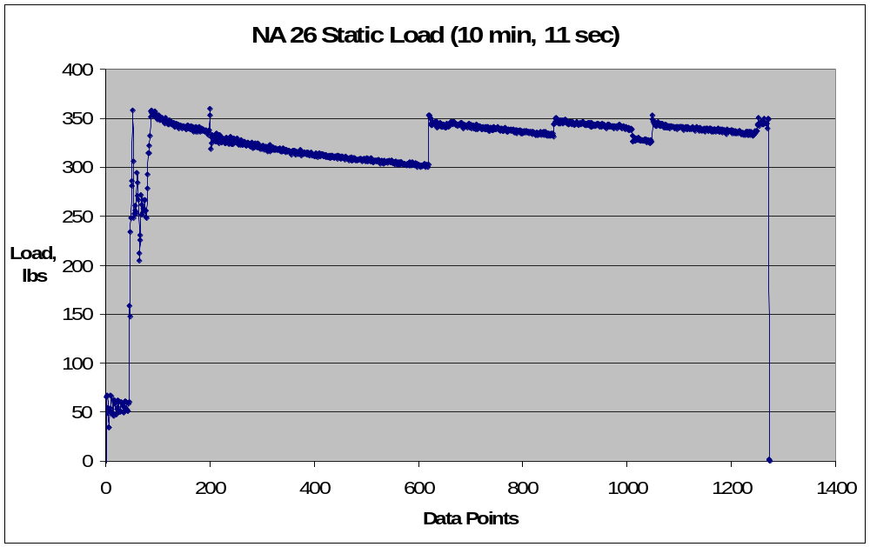

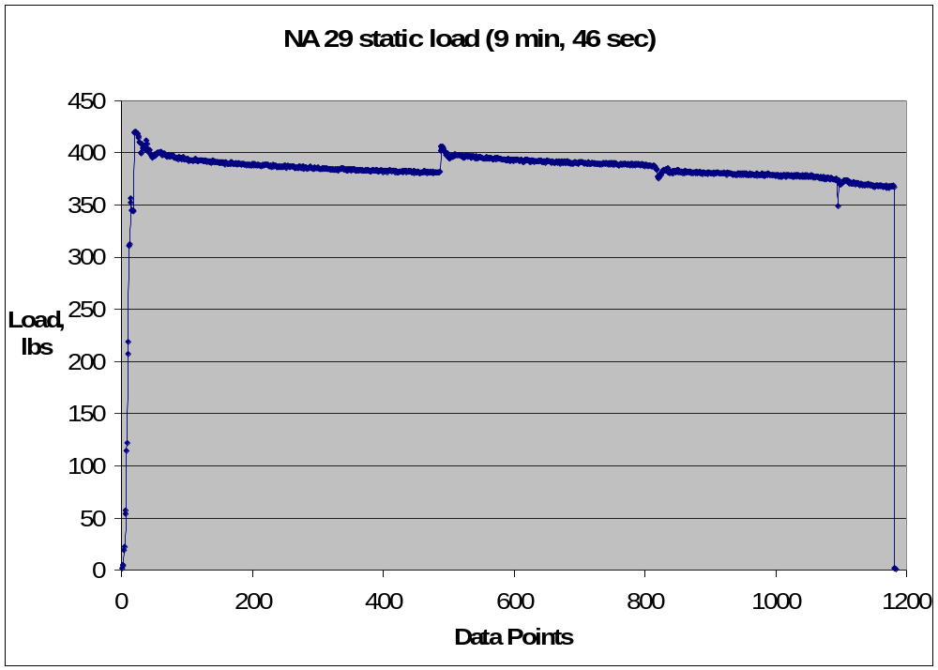
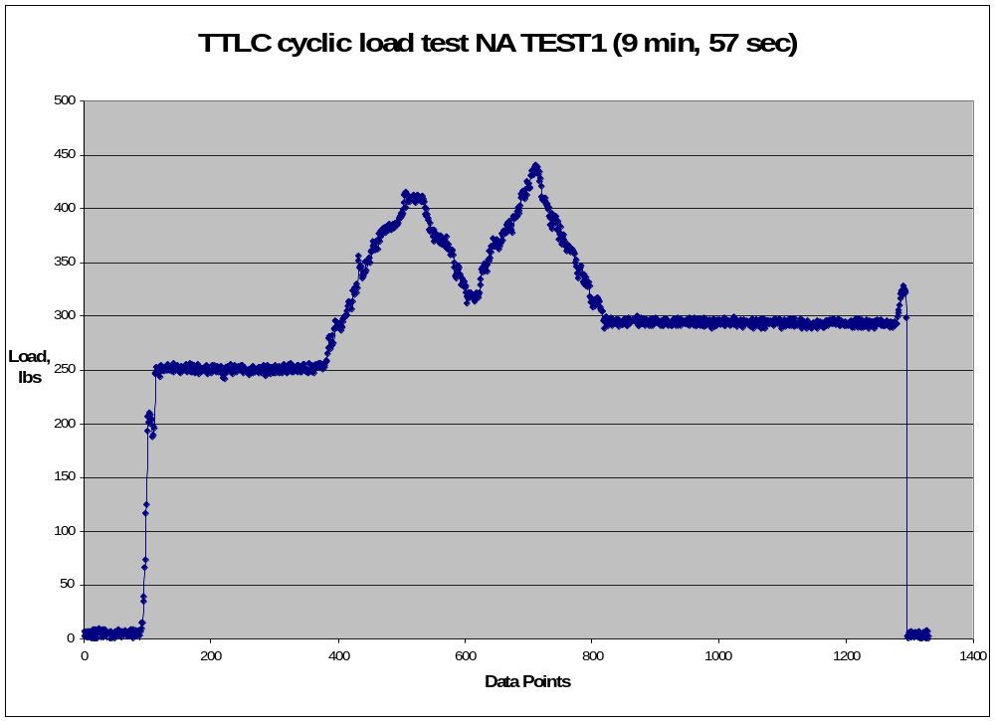
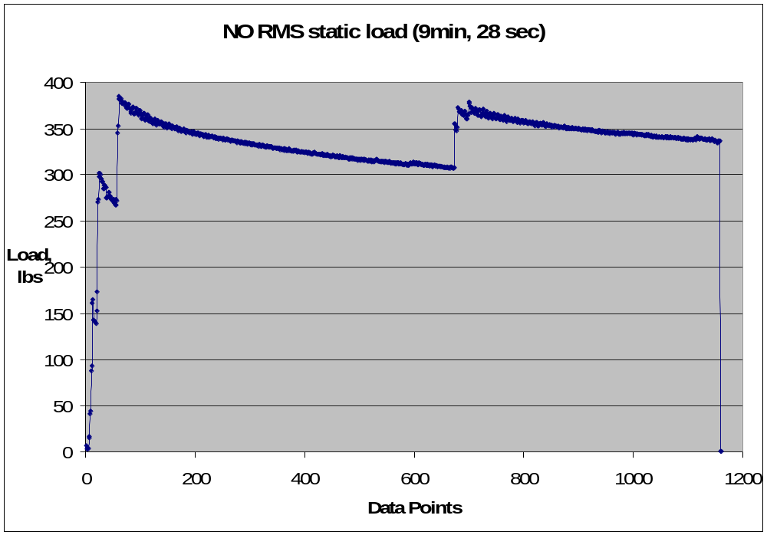
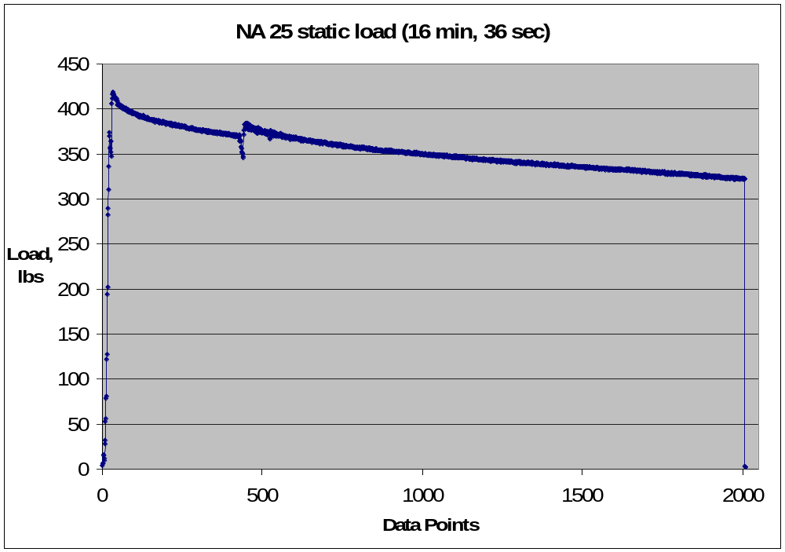
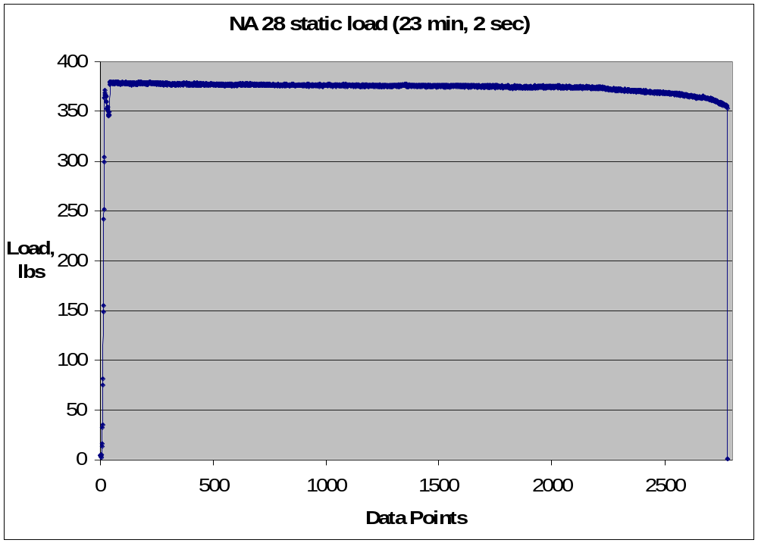
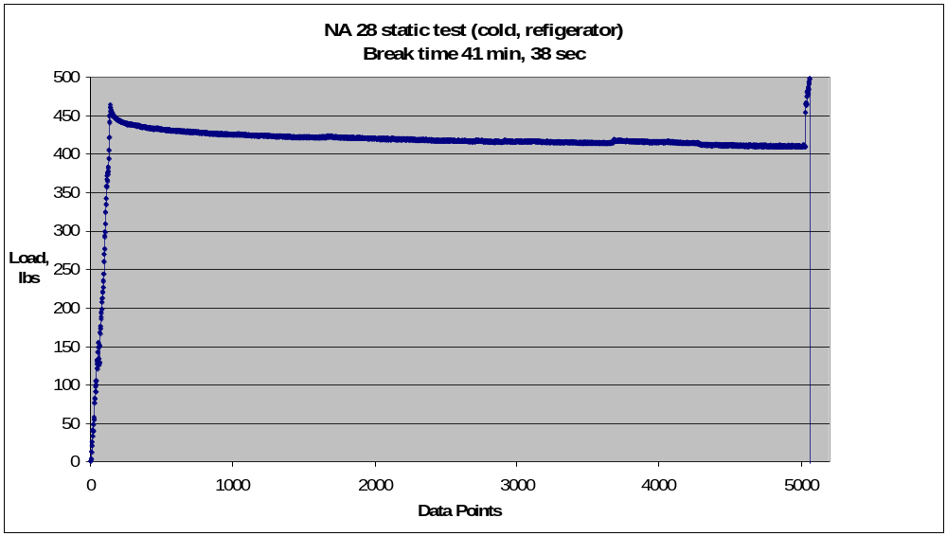

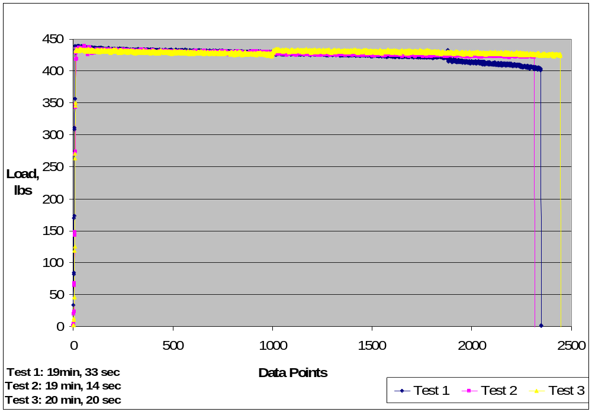

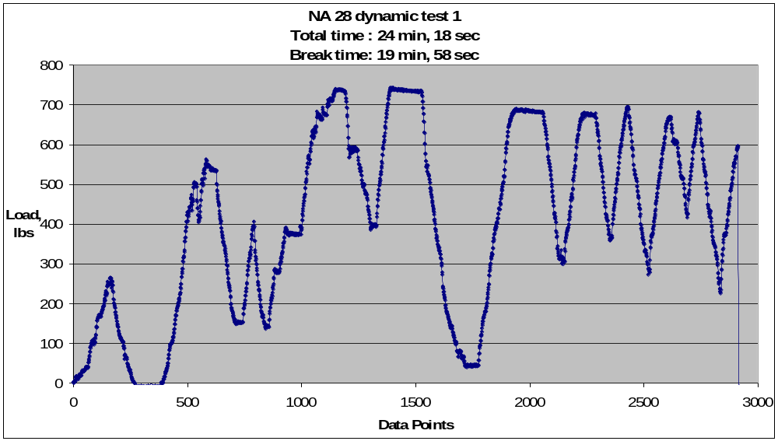

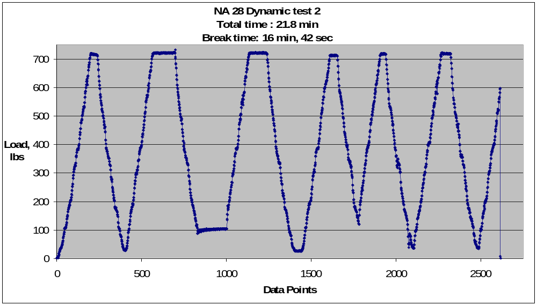

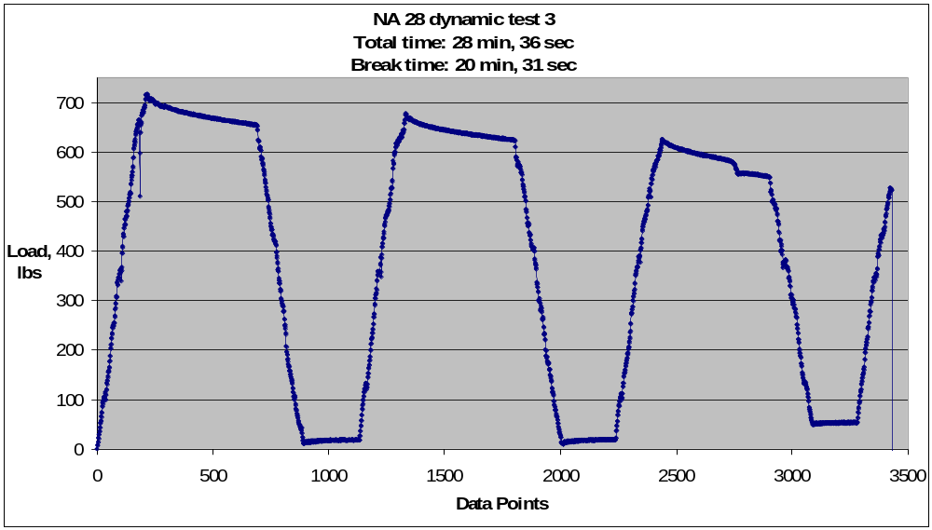

Appendix B: TLC results

The following plots are load vs. time for all the TLC testing. The horizontal axis is actually the number of the data points sampled by the A/D converter. The A/D was sampling at 2Hz, or two samples per second. Hence the time in the test is the number of points divided by two (2).


